Ventilation

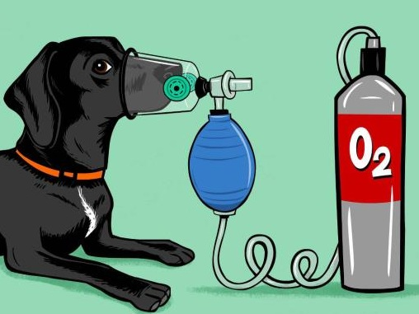
What is ventilation?

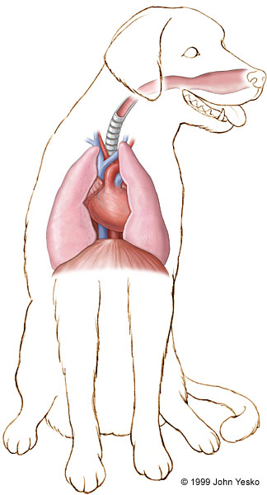
The passage of air into the lungs to supply the body with oxygen is known as inhalation, and the passage of air out of the lungs to expel carbon dioxide is known as exhalation: this process collectively is called ventilation or breathing

Why is ventilation important?

Sometimes an animal will have trouble breathing on its own, so the veterinarian must intervene with mechanical or artificial ventilation.

If the patient stops breathing, the lack of oxygen and excess of carbon dioxide in the blood will cause almost immediate loss of consciousness. Brain cells start dying as little as 5 minutes after being deprived of oxygen. Though the heart continues to beat briefly, death will follow in a matter of minutes unless emergency measures are taken to get breathing started again.

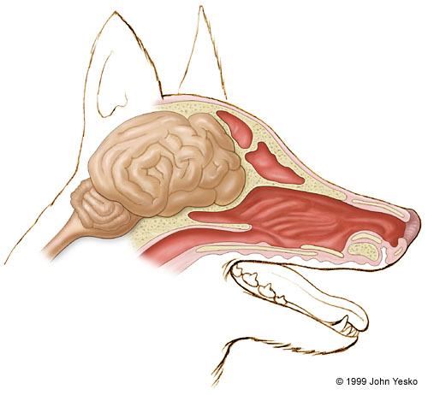

How do we ventilate?

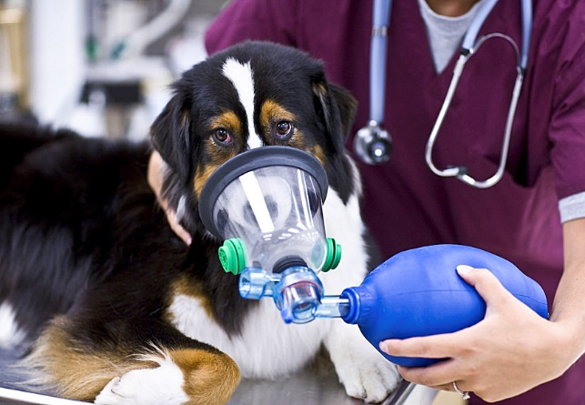
Positive pressure with mask and bag

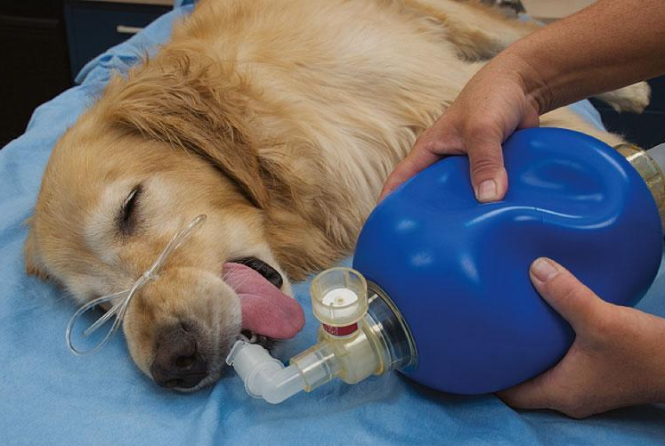
Positive pressure with endotracheal tube and bag

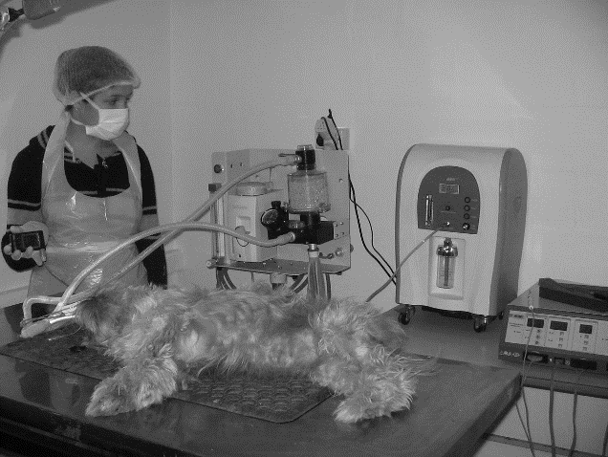
Positive pressure with endotracheal tube and ventilation machine

What are the goals of ventilation?

- Maintain an arterial blood carbon dioxide level (PaCO2) of 35-60 mmHg

- Maintain a blood oxygen level (PaO2) of 80-120 mmHg

- Maintain an oxygen saturation of hemoglobin (spO2) of 95%-100%

- Avoid ventilation induced lung injury and other consequences of positive pressure ventilation
General Guidelines for Ventilation

- Peak inspiratory pressure (PIP) of 10-20 mmHg (the highest level of pressure applied to the lungs during inhalation)

- Peak end-expiratory pressure (PEEP) of 0-2 mmHg (the pressure in the lungs above atmospheric pressure)

- Ventilatory rate of 10-20 breaths per minute

- Tidal volume (VT) of 6-10 mL/kg (normal volume of air displaced between normal inhalation and exhalation when extra effort is not applied)
