Venipuncture
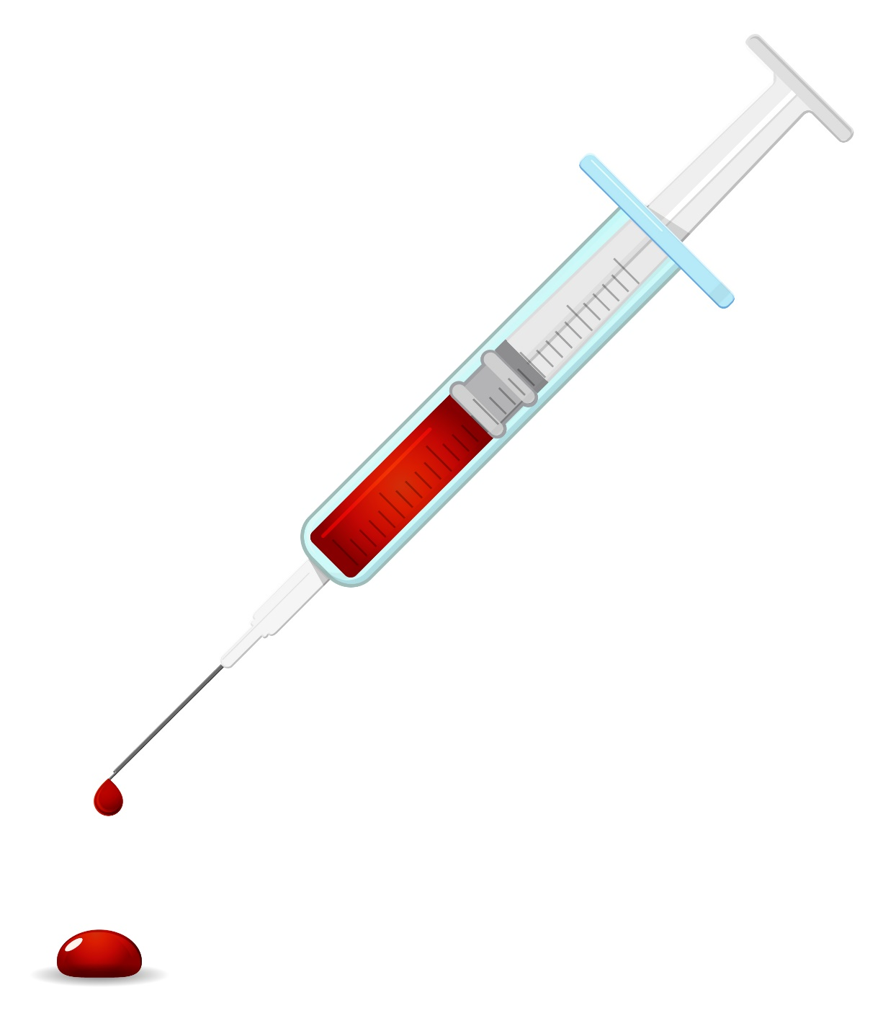

Why do we need blood in vet med?

Blood can help us make a diagnosis or give direction for further diagnostic tests.

Blood cell count
- Too little of one cell type (anemia, autoimmune)
- Too much of once cell type (inflammation, neoplasia)

Blood smear or wet mount
- Evidence of infection (bacteria, fungus, parasites)

Blood chemistry
- Electrolyte imbalance
- Organ function indicators (kidneys, liver and pancreas)
- Indicator of disease (Diabetes, hypothyroidism, Addison’s)

Blood typing
- Prior to blood transfusion

Blood clotting
- Partial thromboplastin time (PTT)
- Prothrombin time (PT)
- Activating clotting time (ACT)

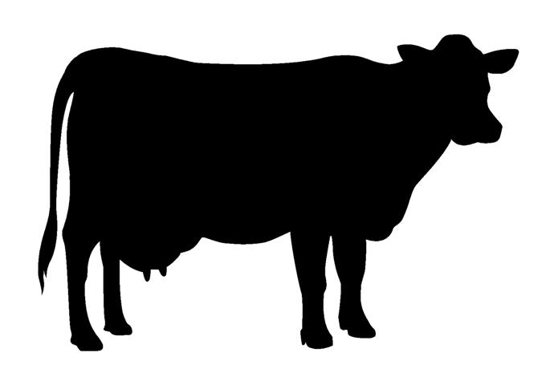
Where do we get blood?
Jugular vein
Transverse facial vein
Jugular vein
Coccygeal vein
Where do we get blood?
Lateral saphenous vein
Jugular vein
Cephalic vein
Lateral saphenous vein
Where do we get blood?
Jugular vein
Cephalic vein
Jugular vein
Medial saphenous vein
Blood Draw Tips

- Gather all supplies ahead of time including blood tubes
- Choose syringe and needle size
- If possible, clip fur from venipuncture site
- Clean venipuncture site with alcohol
- Move syringe plunger to make sure it won’t stick
- Make sure plunger is pushed in before inserting
- Choose insertion site as distal as possible
- Insert needed with sharpest point downward
- Slowly pull on plunger to draw blood
- Redirect needle while still inserted to find vessel
- Stop pulling on plunger when ready to remove needle
- Place pressure on the venipuncture site for 15 seconds
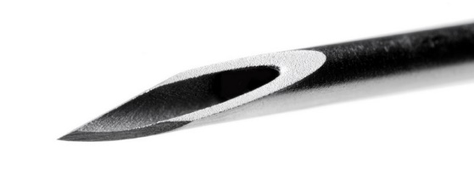
- Check venipuncture site for bleeding

