Arkansas
4-H Veterinary Science
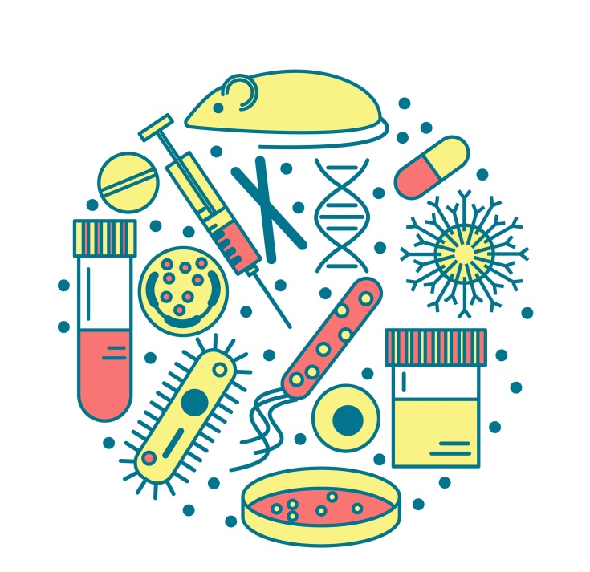

Urinalysis

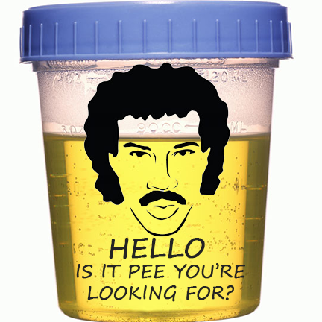

Why Urine?

- Urine is the end product of a filtering process that removes waste from the body

- The color of urine can give you information about hydration level as well as possible underlying disease

- A urinalysis should be performed at least yearly for healthy pets, and more often for older animals and those with existing or chronic health issues

- Important elements of a urinalysis include a visual inspection of the urine sample, a dipstick test, and microscopic evaluation of urine sediment
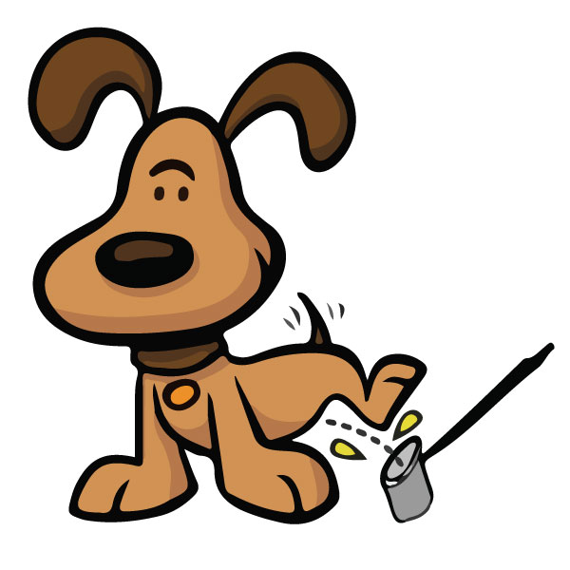

The Urinary System

- The Urinary tract consists of the kidneys, the ureters, the bladder, the urethra, and finally, the urethral opening at either the end of the penis or just within the vagina

- Kidneys filter out waste products from the blood

- Ureters Connect the kidneys to the bladder

- The Urethra is a tube that is controlled by a sphincter muscle that empties the bladder to the outside world

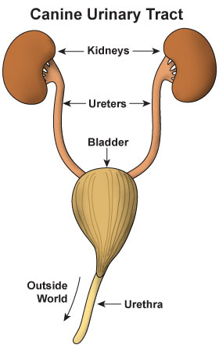

The Bladder

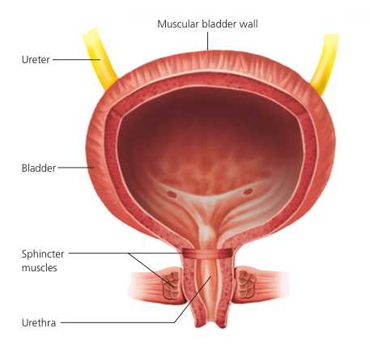
Trigone
Ureteral
Opening
Detrusor muscle
Ureter
Bladder
Sphincter
Muscles
Urethra
Bladder Neck

Urinary Tract Problems

- Inflammation of bladder caused by stress

- Bacterial or fungal bladder infections

- Inflammation of bladder from urinary crystals

- Inflammation of bladder from bladder stones

- Inflammation of the urethra

- Damage to ureters by trauma, passing kidney stones, surgical accident or cancer

- Damage to kidneys by dehydration, infection, toxins or cancer
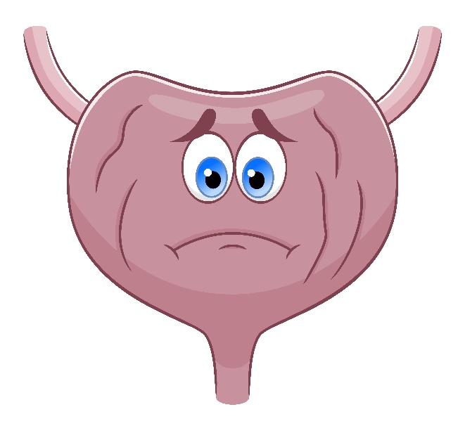

Feline Idiopathic Cystitis

- Inflammation of the bladder with an unknown cause

- Can quickly lead to kidney and heart problems

- Can lead to total blockage of urethra in males

- Frequent attempts to urinate

- Straining to urinate

- Urinating in inappropriate places in the house

- Crying out during attempts to urinate

- Blood-tinged urine

Bladder Infection

- Bacterial or fungal contamination via urethra

- Can lead to kidney infection

- Frequent attempts to urinate

- Straining to urinate

- Urinating in inappropriate places in the house

- Crying out during attempts to urinate

- Blood-tinged urine

- Cloudy and odorous urine
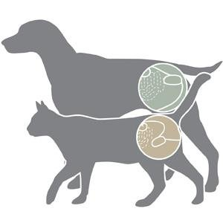

Bladder Cancer

- Causes an obstruction within the urinary tract
- More common in dogs
- Transitional cell carcinoma is most common type
- Cancer is very aggressive
- Symptoms are similar to bladder infection
- Should always be considered if blood is in urine
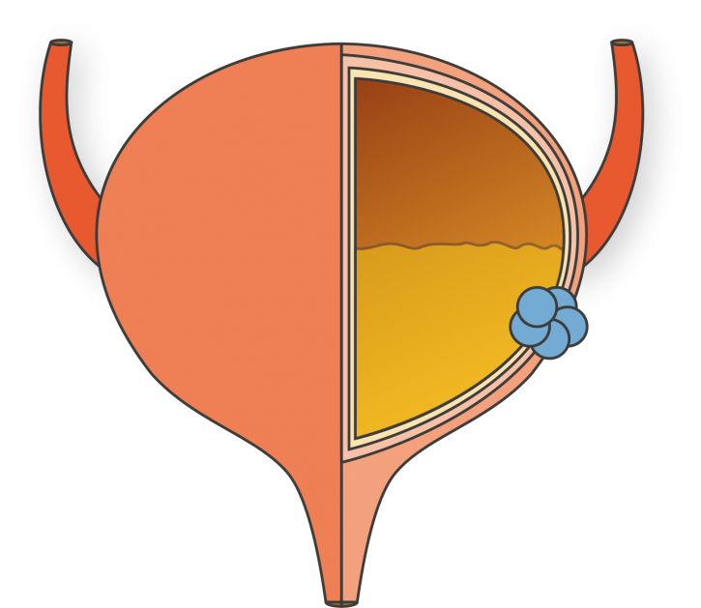

Visual Characteristics of Urine

Color
Clear to yellow is normal
Dark yellow to brownish yellow indicates dehydration
Brown to dark brown indicates muscle damage
Pink, Orange or Dark Red indicates blood

Clarity
Clear is normal
Cloudy may indicate infection or inflammation
Precipitates may indicate neoplasia (cancer)

Urine stream
Urination should occur in a steady stream
A slow stream indicates a problem
Leakage (incontinence) indicates a problem
Posturing to urinate without urine is called anuria

The Dipstick Test

Urine pH is affected by many variables, including time since the last meal, diet, a number of medications, lung and kidney function, and a renal and systemic diseases.
Blood in urine can occur with disease anywhere in the urogenital tract.
Leukocytes (white blood cells) in urine indicates active inflammation in the urogenital tract.
Glucose in urine means that either the glucose in blood is elevated or there is a kidney disease that prevents full reabsorption of glucose.
Bilirubin in urine occurs with hemolysis (break down of red blood cells) or liver disease.
Protein in urine is due to pre-glomerular, glomerular, or postglomerular disease. The glomerulus is a cluster of capillaries around the end of a kidney tubule, where waste products are filtered from the blood.
Ketones in urine are formed when the body is unable to get sufficient energy from glucose and must metabolize large quantities of fatty acids instead.
Specific gravity is an indirect measure of kidney function.

Urine Sediment

