Teeth
Laboratory

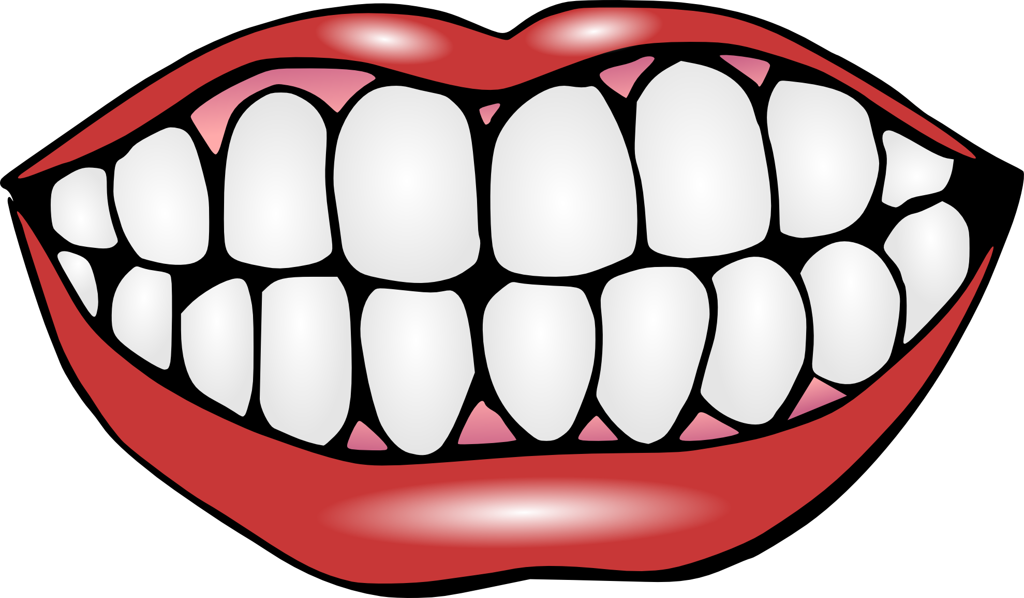

Definitions

- Veterinary Dentistry: __________________________________________________________________________________________________________________________

- Periodontal Disease: __________________________________________________________________________________________________________________________

- Tartar: __________________________________________________________________________________________________________________________

- Plaque: _____________________________________________________________

- Gingivitis: __________________________________________________________________________________________________________________________

- Lingual: _____________________________________________________________

- Buccal: _____________________________________________________________

- Occlusal: _____________________________________________________________

- Rostral: _____________________________________________________________

- Caudal: _____________________________________________________________

Canine Teeth

Permanent teeth eruption:
- Incisors: 105-125 days
- Canines: 125-141
- P1 : 110-150 days
- P2/P3 : 150 days
- P4 : 135-185 days (completed)
- M1 : 140-165 days
- M2 : 160-220 days
- M3 : 180-220 days

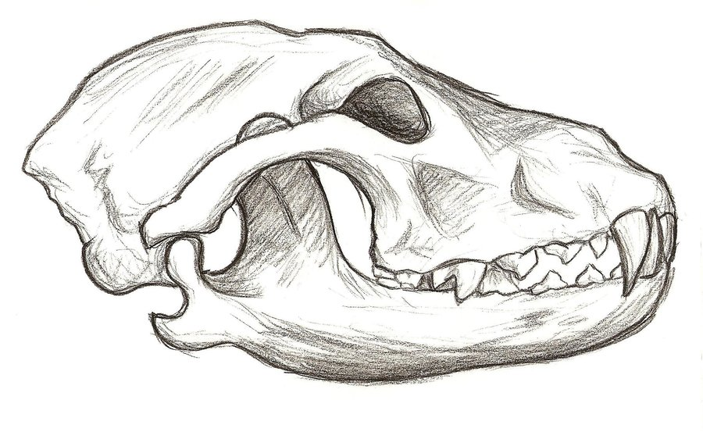

Feline Teeth

Permanent teeth eruption:
- Incisors : 103-135 days
- Canines : 149-153 days
- Premolars : 150-174 days
- Molars : 130-162 days

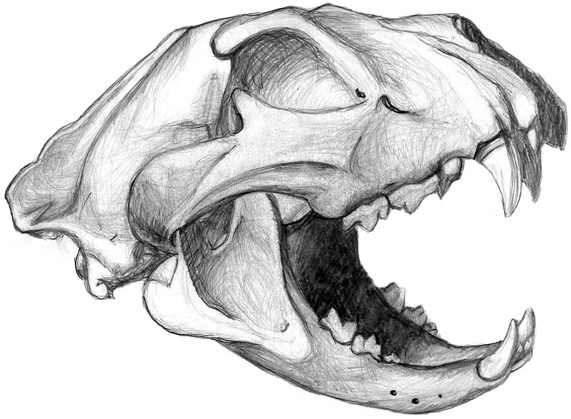

Horse Teeth

Permanent teeth eruption:
- 1st Incisors: 2 ½ years
- 2nd Incisors: 3 ½ years
- 3rd Incisors: 4 ½ years
- Canines: 4 to 5 years
- P1 (wolf tooth): 5 to 6 months
- P2: 2 ½ years
- P3: 3 years
- P4: 4 years
- M1: 9 to 12 months
- M2 : 2 years
- M3 : 3 ½ to 4 years
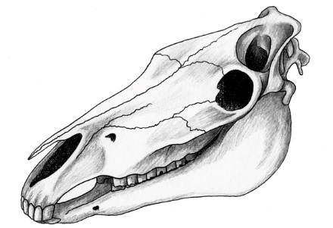

Dental Problems

Congenital Malformation
- Retrognathism (overbite, parrot mouth or dorkfish)
- Prognathism (underbite or monkey mouth)

Retained Deciduous Teeth
- Canine teeth are most commonly retained in carnivores
- Retained teeth will damage permanent teeth

Periodontal Disease
- Stage I
- Stage II
- Stage III
- Stage IV

Fractures
- Enamel only
- Enamel and pulp
- Root
- Jaw bone

Malformation from chewing
- Hooks
- Ramps
- Enamel points
- Wavemouth

