Sutures

Types of Suture

- Absorbable- no need to remove
- Gut
- Vicryl
- PDS

- Non-Absorbable- must remove
- Nylon
- Silk

- Monofilament
- Used to close delicate tissue
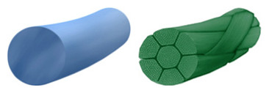
- Used to prevent reactions
- Used to prevent infection

- Multifilament
- Used to provide better knot security
- Causes much more inflammation
- For sterile surgical sites only
- More apt to cause infection

Suture Sizes

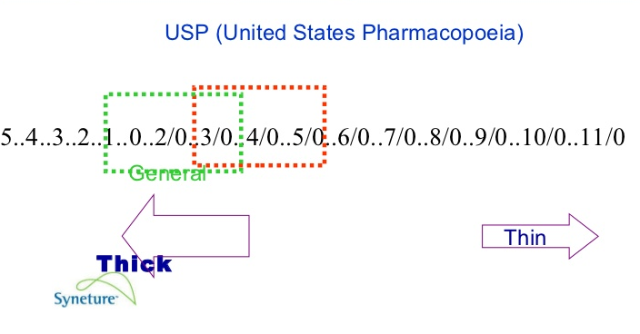

Needle Choices

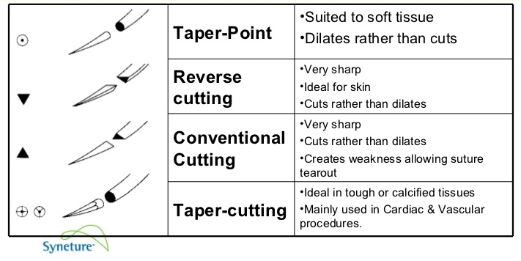

Suture Patterns

- Simple interrupted
- Simple continuous
- Horizontal Mattress
- Vertical Mattress
- Cruciate
- Subcuticular

Simple Interrupted

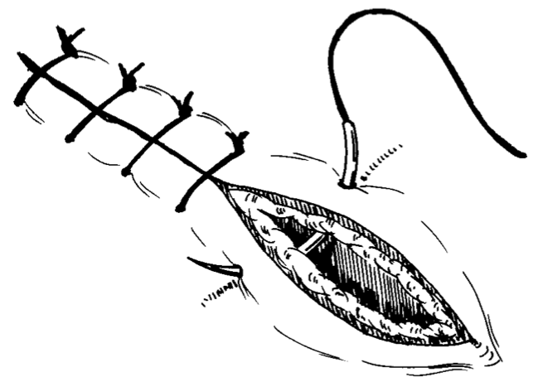

Simple Continuous

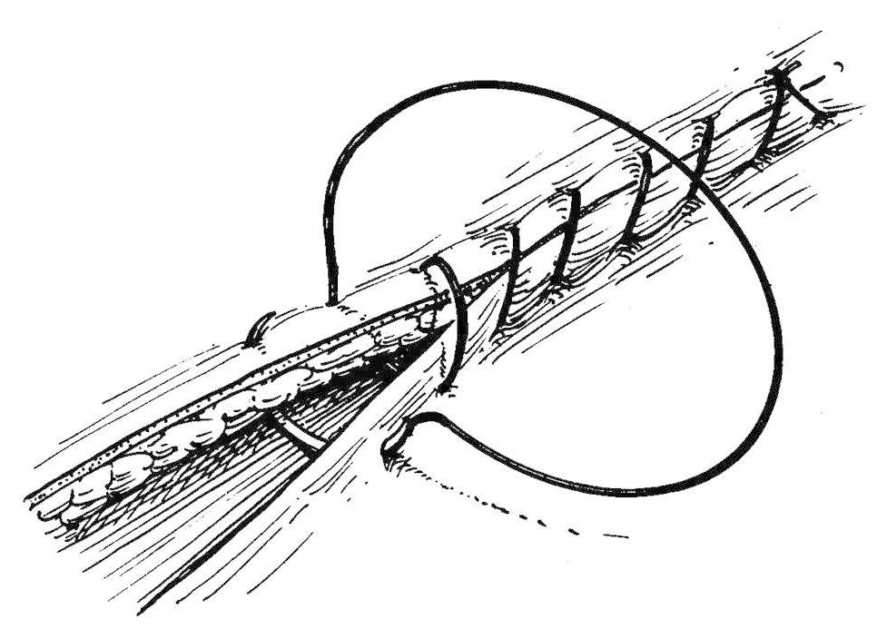

Horizontal Mattress

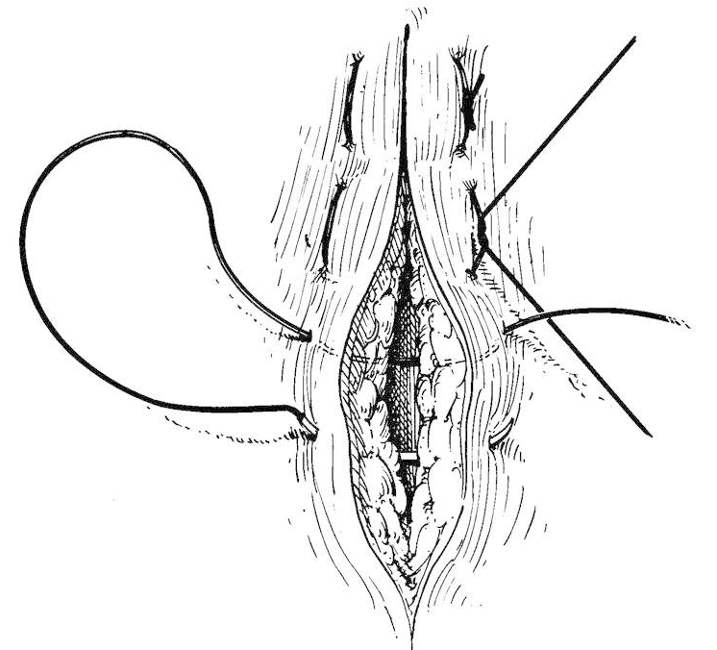

Vertical Mattress

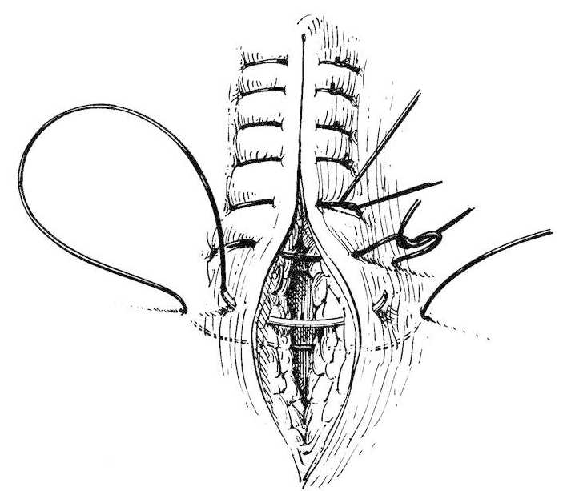

Cruciate

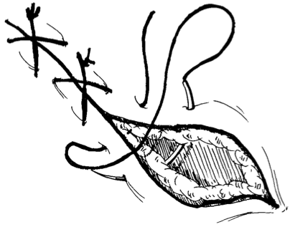

Subcuticular

