Surgery Pack
Wrapping

The Spay Pack
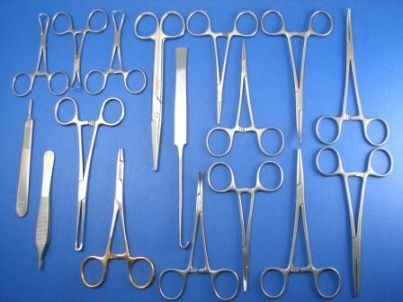

Mayo Scissors
(for cutting thick tissue)

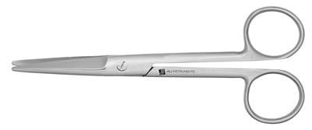

Scalpel Handle
(for holding scalpel blade)

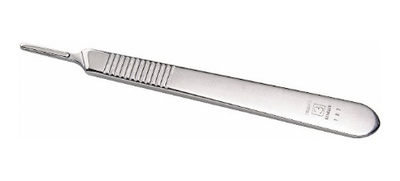

Spay Hook
(for finding uterine horns)

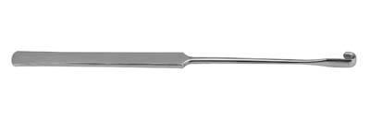

Kelly Hemostat
(for clamping moderate vessels)

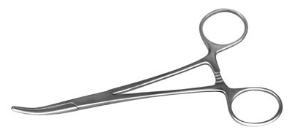

Metzenbaum Scissors
(for cutting thin tissue)

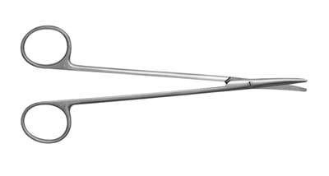

Tissue Forceps
(for grasping delicate tissue)

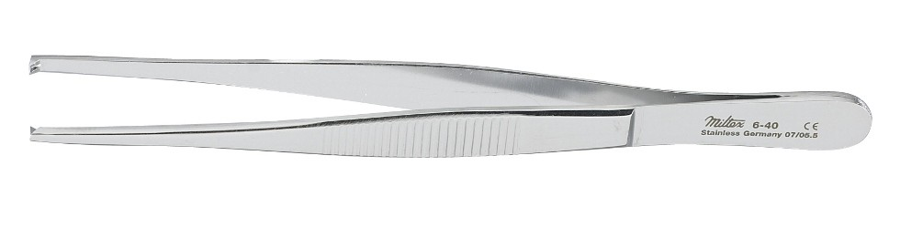

Adson-Brown Forceps
(for grasping more fibrous structures)

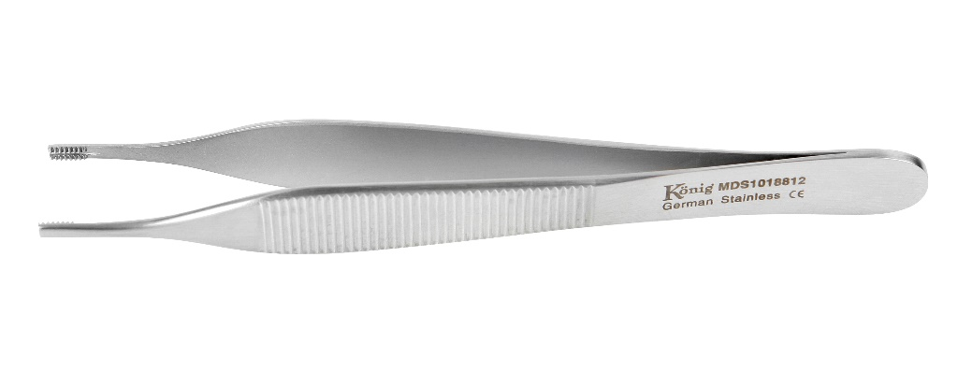
Allis Forceps
(for grasping/holding delicate tissue)

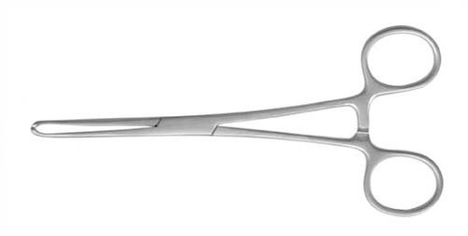

Towel Clamp
(for clamping towel to skin)

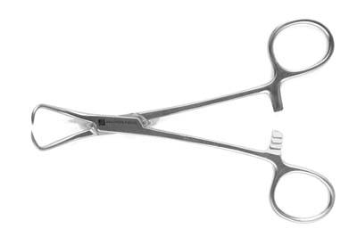

Needle Holder
(for holding suture needle)

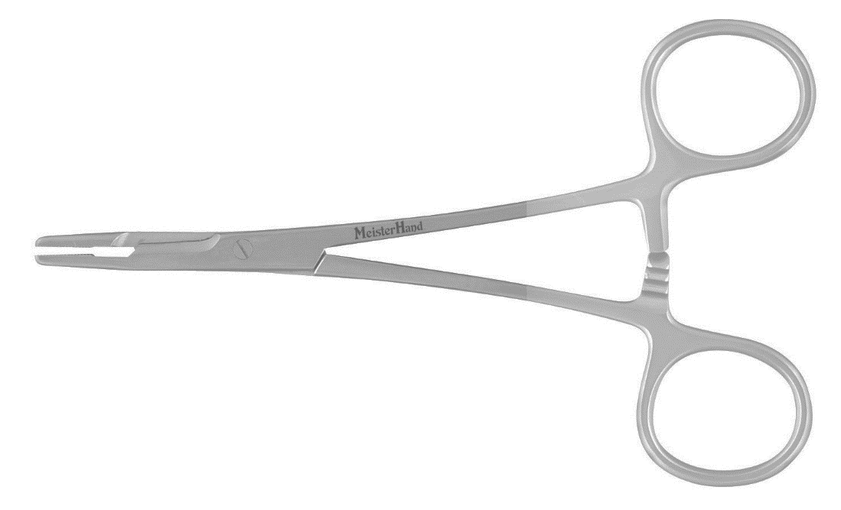

Mosquito Forceps
(for clamping small vessels)

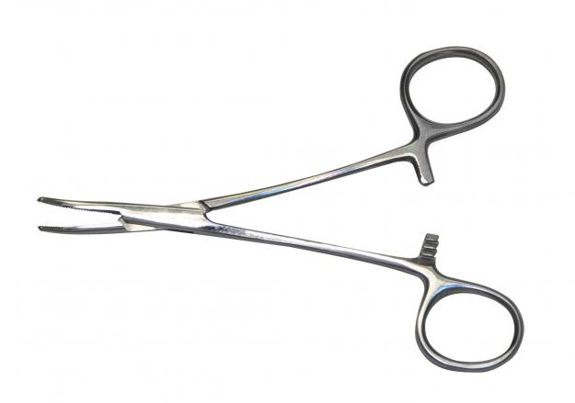

Carmalt Forceps
(for clamping large vessels/structures)

