Sterile
Technique

What is Sterile (Aseptic) Technique?

Aseptic technique is a method designed to prevent contamination from microorganisms. It involves applying the strictest rules and utilizing what is known about infection prevention to minimize the risks that the patient will experience an infection.

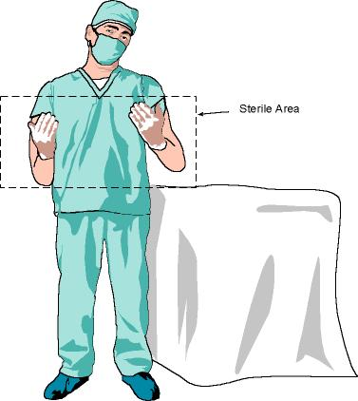

Scrubbing in for Surgery
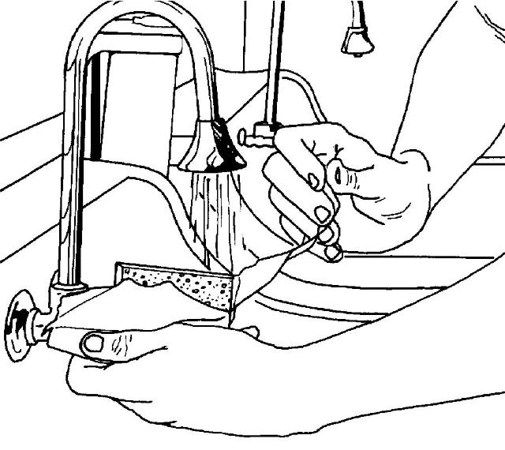
- Open sterile soap packet

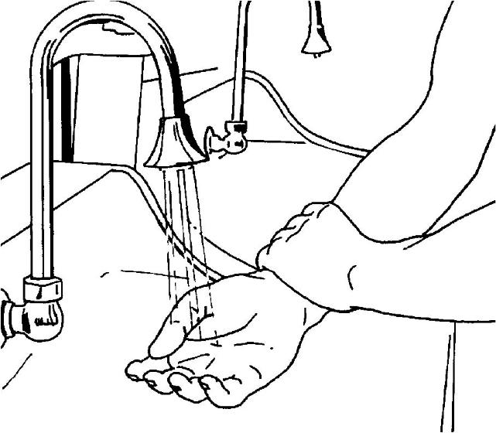
- Wet hands

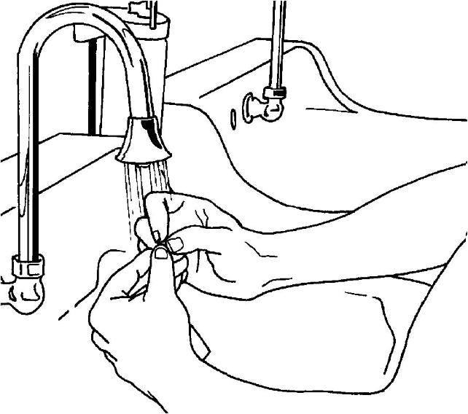
- Clean under fingernails first

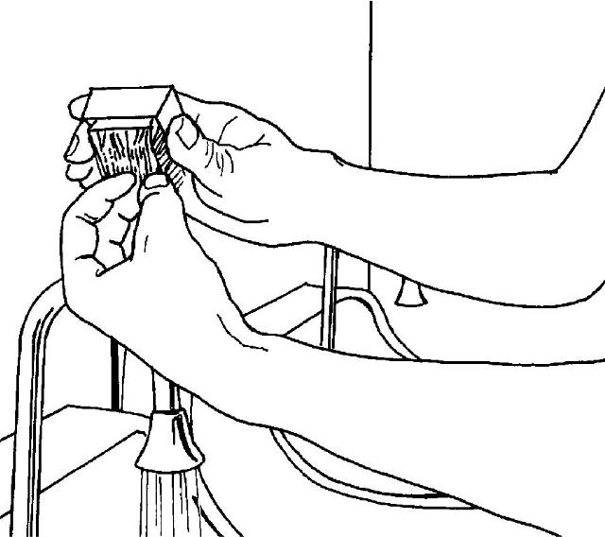
- Lather and scrub fingertips
30 circular strokes

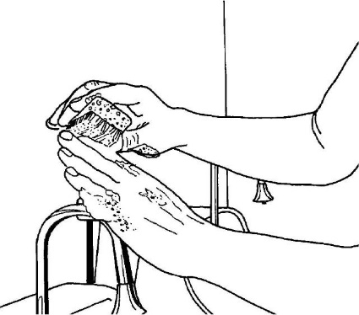
- Lather and scrub digits
20 circular strokes on all 4 sides

- Scrub arm up to elbow
1 minute each side

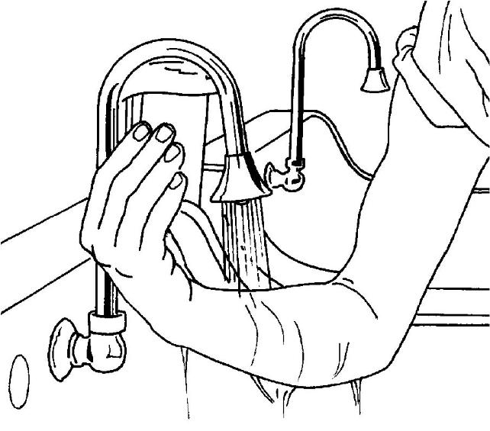
- Repeat on other hand and arm

- Rinse starting with hands
Allow water to flow toward elbow

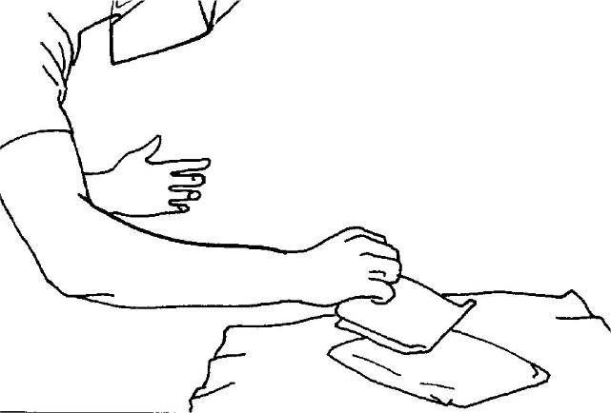
- Carefully pick up sterile towel

- Dry from hands to elbow

Now you are ready to gown!

Gowning for Surgery
