Small Animal
Restraint

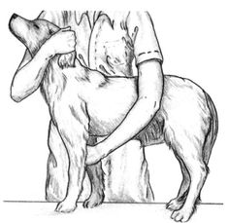

Sitting Restraint

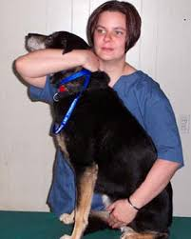

- Move one arm under jaw and hug head to body
- Move other arm in front of hip and grasp under belly
- Used for examinations and injections

Standing Restraint

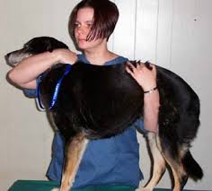

- Move one arm under jaw and hug head to body
- Move other arm in front of hip and grasp under belly
- Used for examinations and injections

Restraint for Saphenous Vein Access

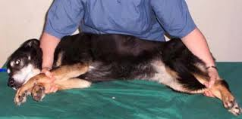

- One arm goes over neck and grasps the bottom leg
- Other arm goes over hip and grasps the bottom leg
- If small dog or skinny legs, grasp both legs
- Used mainly for bandage changes or small blood volume draws from lateral saphenous vein

Restraint for Cephalic Vein Access

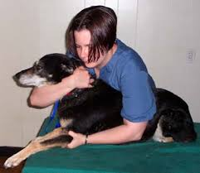

- One arm under the jaw and hugging head to body
- Other arm pressed against flank and grasping elbow
- Thumb grasps the medial skin and twists laterally to expose vein
- Used mostly for IV catheter placement or small volume blood draw

Restraint for Jugular Vein Access

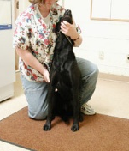

- One arm under the jaw and hugging head to body
- A muzzle is recommended for this hold
3. Leg behind back to prevent dog from backing up
4. Other arm stabilizing body by grasping limb or
holding arm across the dog’s chest
5. Used for large volume blood draw

Restraint for Cat Jugular Vein Access

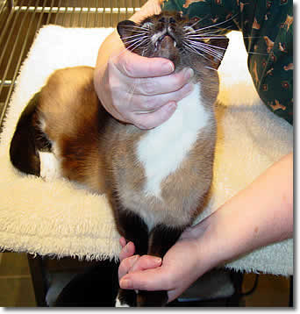

- One hand under jaw
- A muzzle is recommended for this hold
- Other hand holds both front legs and stretches
- Used for large volume blood draw

Restraint for Cat Medial Saphenous Access

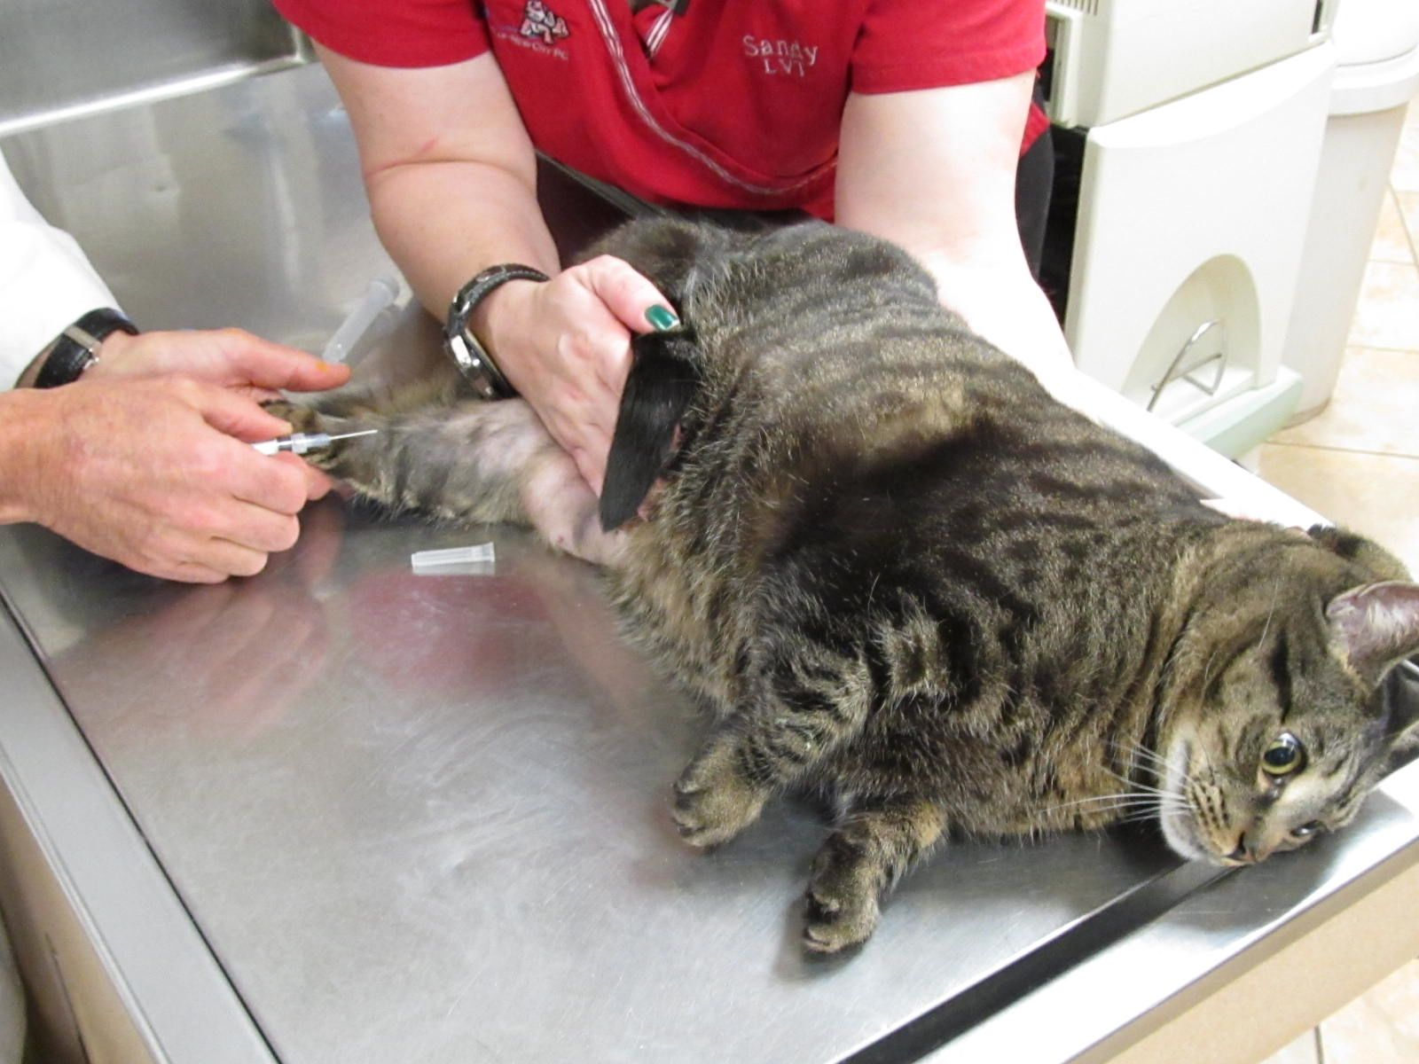

- Use one hand to hold scruff of neck
- Use other hand to hold top foot and press on lower thigh (like a karate chop)
- Stretch to keep front claws from reaching back leg
- Used for any volume blood draw

