Microscope
Laboratory

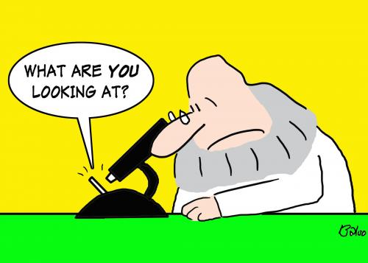

The Compound Microscope
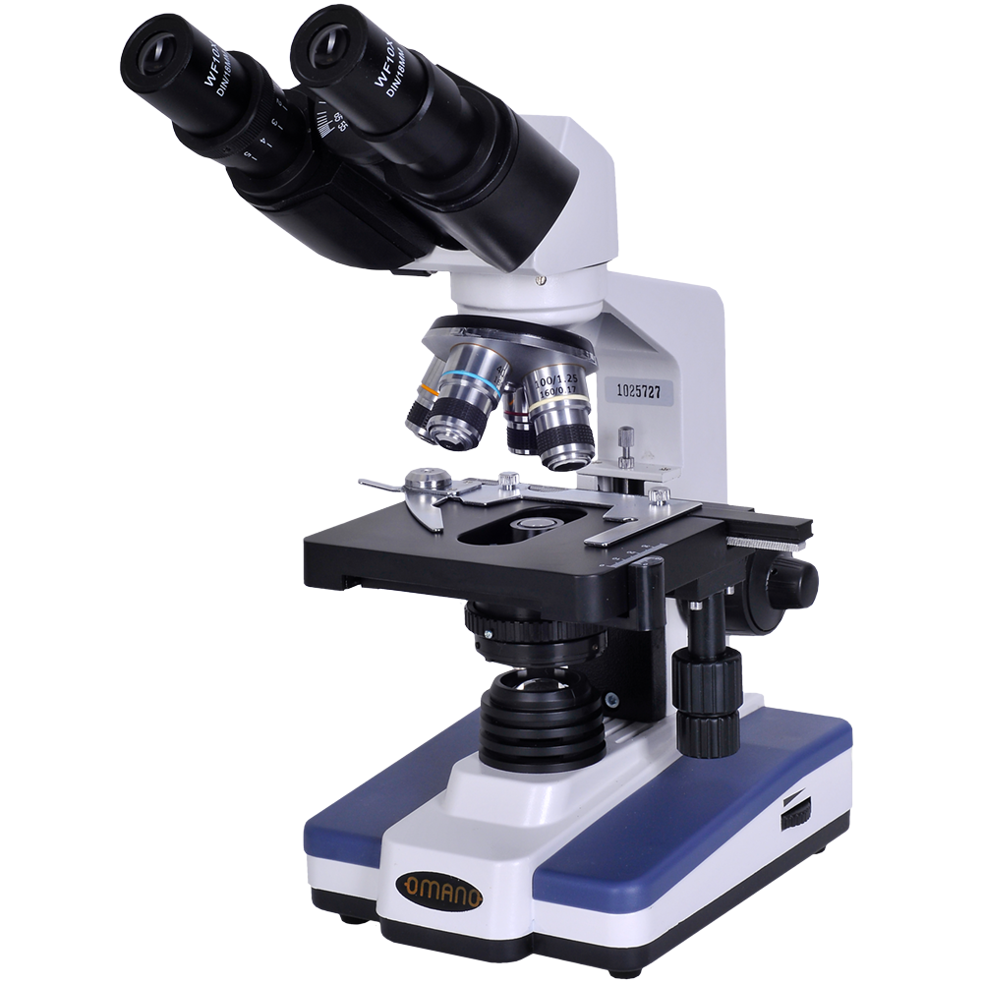

The Animal Cell

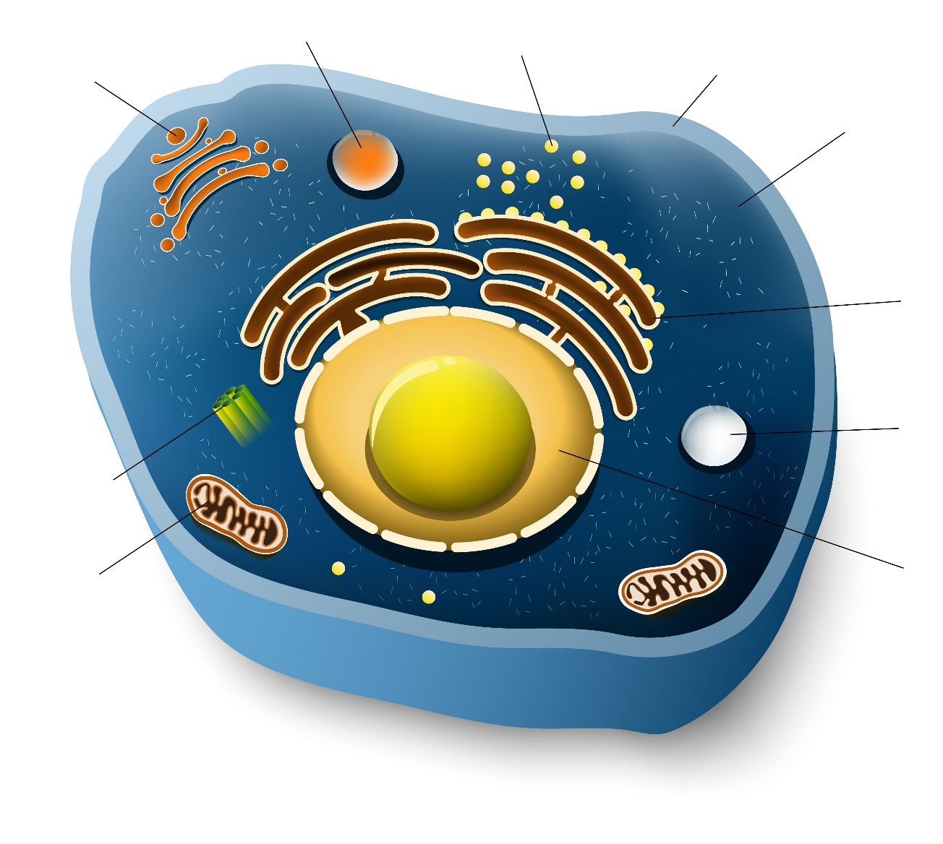

Parts of the Animal Cell

____Nucleus
____Membrane
____Cytoplasm
____Rough Endoplasmic Reticulum
____Ribosomes
____Golgi Apparatus
____Centriole
____Mitochondrion
____Peroxisome
____Lysosome

- the site of biological protein synthesis (translation)
- provides the main source of energy- ATP
- contains most of the genetic material of the cell
- organelle that breaks down long chain fatty acids
- packages proteins into membrane-bound vesicles
- synthesizes and exports proteins and membrane lipids
- the gel-like substance enclosed within the cell membrane
- contains enzymes that break down biomolecules
- structure that aid in the organization of cell division
- separates cell from the extracellular environment

Select Cell Functions

___Goblet Cell
___Chief Cell
___Parietal Cell
___Type I Alveolar Cell
___Type II Alveolar Cell
___Macrophage
___Neuron
___Red Blood Cell
___Platelet
___Neutrophils

- transmits information by electrical and chemical signals
- first-responders of immune defense that create pus
- involved in gas exchange
- stops bleeding by clumping and clotting
- engulfs and digests cellular debris
- secretes hydrochloric acid
- delivers oxygen to body tissues
- secretes pulmonary surfactant
- secretes the digestive enzyme pepsinogen
- secretes mucin

