Horse

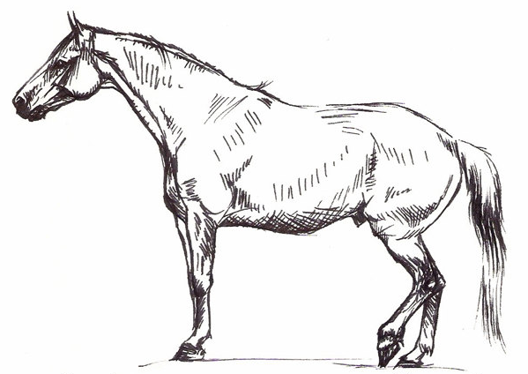

Horse Exam

Vital Signs
- Heart Rate 30 to 40 beats per minute
- Breathing Rate 8 to 15 breaths per minute
- Body Temperature 99-100.5°F
Examination
- Body condition and lameness score
- Eyes, mouth (teeth and gums), skin and hooves
- Reproductive organs
- Listen to gut sounds
- Record vital signs
- Vaccinate and/or treat
Common Problems
- Teeth (lots of wear and tear)
- Eyes
- Hooves
- Gastrointestinal system

Horse hoof
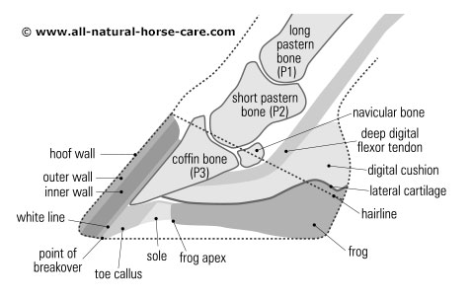
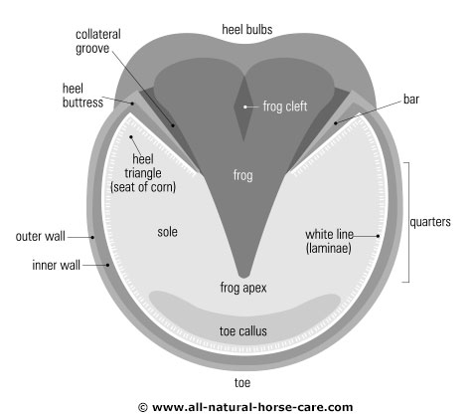

Laminitis

- Also called Founder
- Inflammation of the laminae inside the hoof
- Results from the disruption of blood flow to laminae
- If severe, bone and hoof wall can separate
- Can affect all or one foot
- Front feet are affected more often
- Inflammation often starts somewhere else in the body
- Digestive upsets from diet
- Sudden access to excessive amounts of lush forage
- Toxins released within the horse's system
- High fever or illness
- Severe colic
- Retained placenta in the mare after foaling
- Excessive concussion to the feet
- Excessive weight-bearing on one leg due to injury - Various primary foot diseases
- Bedding that contains black walnut shavings
- Prolonged use of corticosteroids

Laminitis Risk Factors

- Heavy breeds, such as draft horses
- Overweight body
- feeding large amounts of carb-rich meals
- Ponies, Morgans, miniature horses and donkeys
- Unrestricted grain binges
- Horses who have had previous episodes of laminitis
- Older horses with Cushing's disease

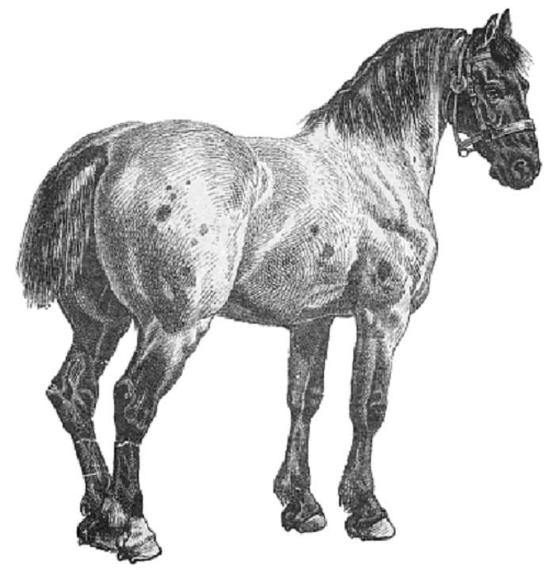

Signs of laminitis

- Lameness, especially when a horse is turning in circles
- Shifting lameness when standing
- Heat in the feet
- Increased digital pulse in the feet
- Pain in the toe region when pressure is applied
- Reluctant or hesitant gait ("walking on eggshells")
- Sawhorse stance with front feet stretched out in front

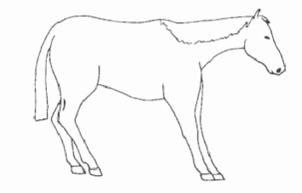

Laminitis Treatment

- Have vet diagnose and treat the primary problem
- Feed only grass hay until advised by your veterinarian
- Purge horse's digestive tract if horse has overeaten
- Administering fluids if the horse is ill or dehydrated
- Antibiotics, anticoagulants and vasodilators to reduce blood pressure while improving blood flow to the feet
- Stabling the horse on soft ground such as sand
- Manage hoof (corrective trimming +/- shoes)
- New therapies such as ice boots or laser therapy

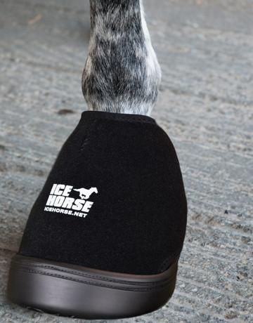

Laminitis management

A modified diet that provides adequate nutrition based on high-quality forage, digestible fiber (beet pulp) and oil. Avoid excess carbohydrates, especially from grain.
Routine hoof care, including regular trimming and, in some cases, therapeutic shoeing (additional radiographs may be needed to monitor progress).
A good health-maintenance schedule, including parasite control and vaccinations, to reduce the horse's susceptibility to illness or disease
A nutritional supplement formulated to promote hoof health.
Avoid grazing lush pastures, especially between late morning and late afternoon hours, since plant sugars are the highest during these times. Restrict pasture intake during spring or anytime the pasture suddenly greens up
