IV Catheters
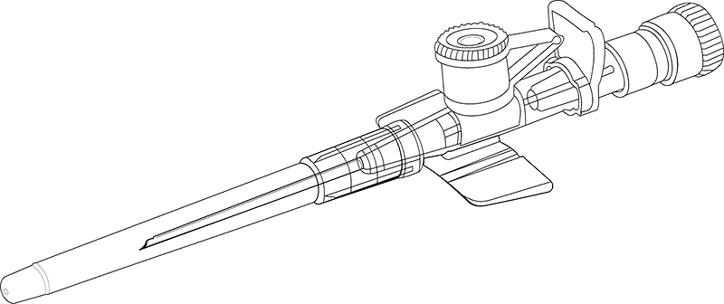
Why do we use intravenous catheters?

- Sampling of blood
- Fluids
- Medications
- Parenteral nutrition
- Chemotherapy
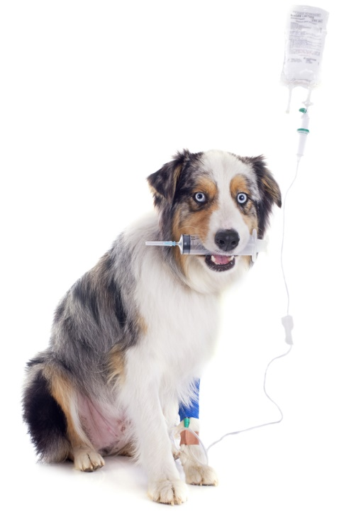
- Blood products
Catheter Basics

- Select the smallest gauge of catheter that can effectively deliver the prescribed therapy
- 24-ga for puppies and kittens
- 22-ga for cats and small dogs
- 20-ga for medium-sized dogs
- 18-ga large dogs and small ruminants
- 14-ga horses
- If patient needs large volumes infused over a short period of time, then select the largest gauge that is likely to fit the chosen vein
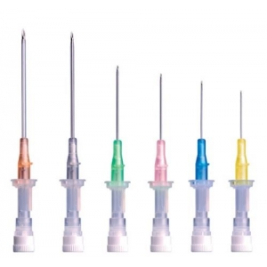

Placing a Catheter

- Clip fur from catheter site around limb
- Scrub skin 3 times with surgical scrub
- Wipe away scrub with alcohol and air dry
- Have assistant hold off vein or use tourniquet
- Insert catheter at 15° to 20° angle
- Look for flash of blood in cannula
- Feed cannula over stylet
- Quickly place cap and tape into place
- Flush catheter with sterile saline
- Replace cap or connect to t-port or fluid line
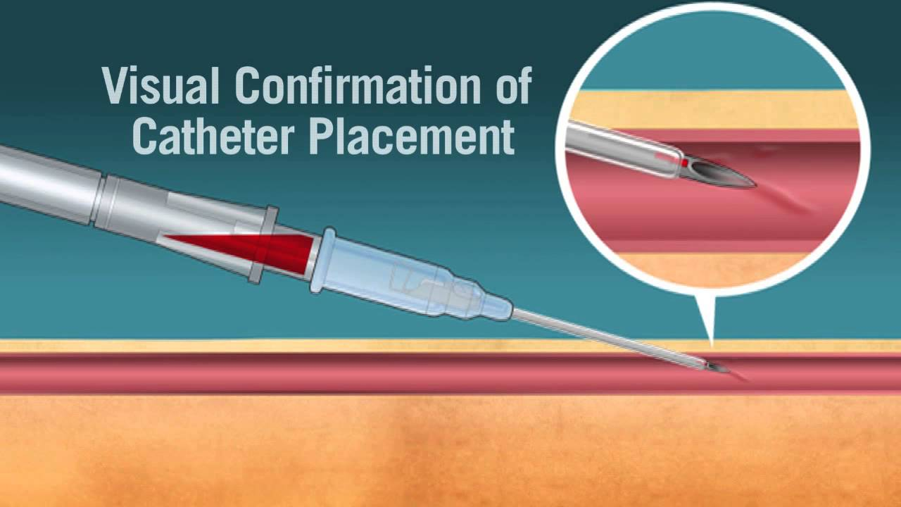
Equipment for catheterization

- Tape – two skinny and one thick with a notch
- Vet wrap (usually red)
- Clean clippers with sharp blade
- Chlorhexidine soaked gauze
- Alcohol soaked gauze
- 2 catheters (one for back up)
- Cap or t-port
- 3 ml syringe with saline flush
- A good assistant!

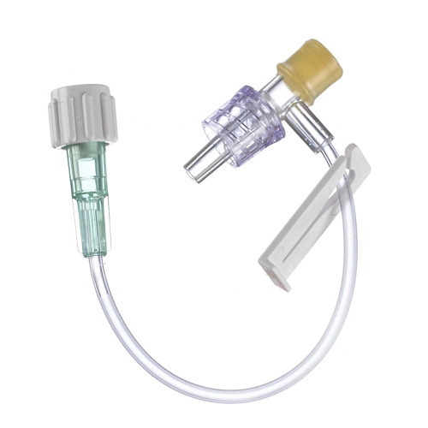

The Perfect Catheter

- Flushes easily
- Fluid can be felt in vein when pushed
- Catheter is not positional
- Catheter is secured
- Does not bother patient

