Horse Handling
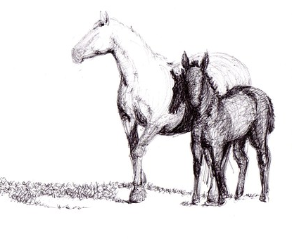
Restraint for Examination

- Observe horse from a distance as part of exam

- Get a respiratory rate prior to handling

- Minimum restraint is a halter and lead rope

- Lead rope can be held by an assistant

- Lead rope can be tied to stationary object

- Refrain from using twitches

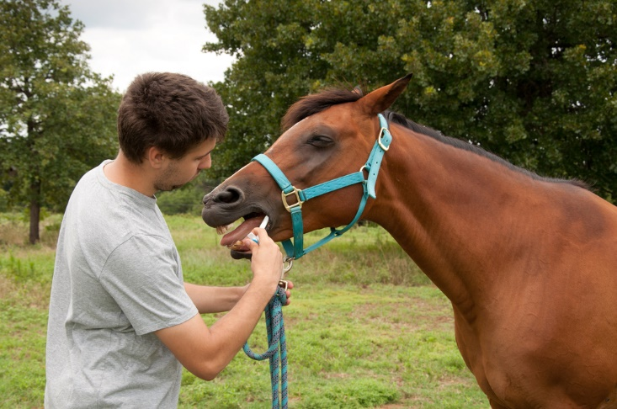

Tying Up a Horse

- Always use a quick release knot

- Never wrap rope around your hand

- Only tie a rope that is connected to a well-fitted halter

- Choose the best place to tie up the horse

- Place the knot at eye level of the horse

- Allow approximately 2-3 feet of slack

- Stand out of kicking range if walking behind horse

- Keep hand on horse as you move along side

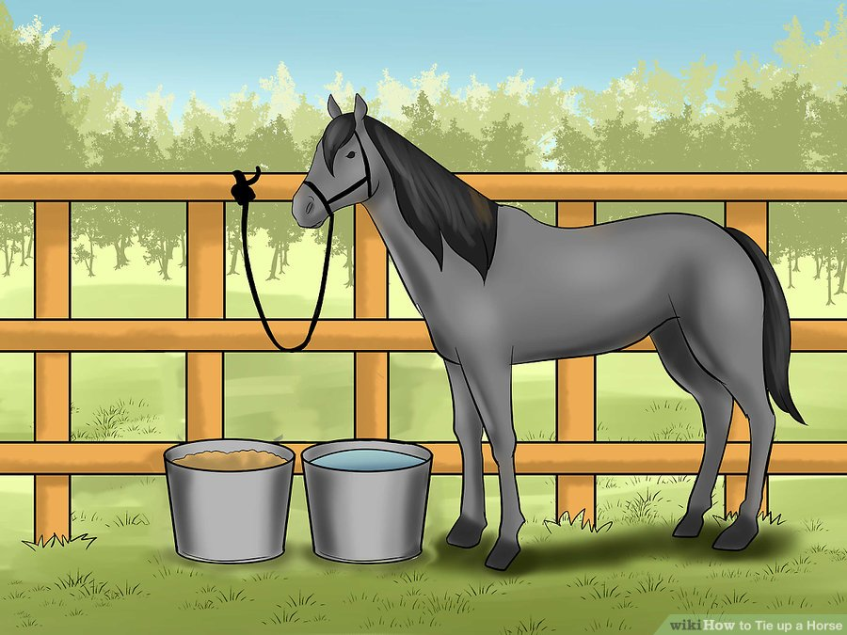

The Highwayman’s Hitch

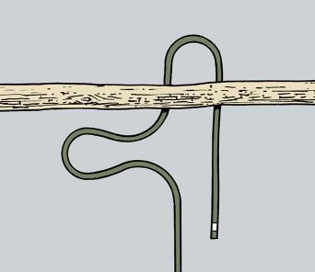
Place a loop under the fixed post, pole, branch, or railing, then form another loop in the standing line.

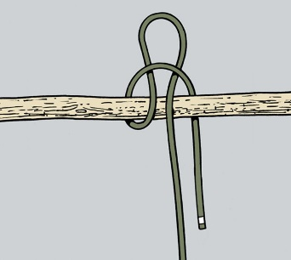
Pull the second loop over the post and under the first loop.

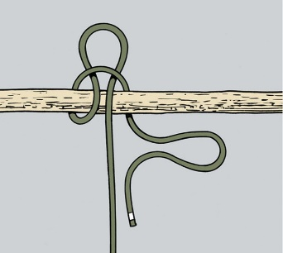
Make a loop in the end of the line…

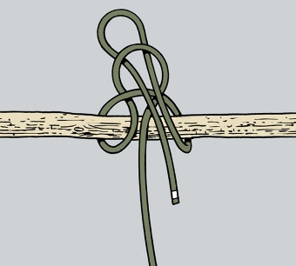
…and thread it through the loop formed at the top of the knot. Pull the standing line to set the knot. To release, pull the end of the free line.

The Mooring Hitch

Make a turn around a post and then form a loop with the free end exiting the loop on the inside.

Grasp the standing line and pull a section through your loop.
Grasp a section of the free end (but not the very end) and pull part way through the new loop.
Tighten the knot by pulling down on the standing line. Release the knot by pulling the free end.

