Honey Bees
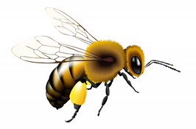
Honey Bee Characteristics

- The queen is the only fertile female
- Drones are males who fertilize the queen
- Workers are sterile females who do everything else!
- The entire colony lives by the queen’s pheromone
- A colony can have up to 40,000 bees
- Bees construct perennial, colonial nests from wax
- Honey and pollen are stored in the nest
- Immature bees are called the brood
- Bees develop from eggs to adults in 28 days
- Brood are reared in hexagonal wax cells
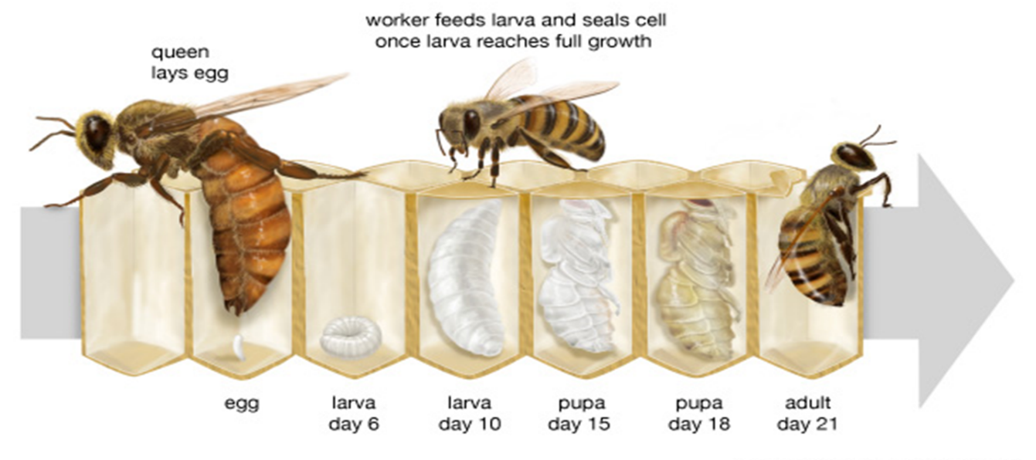
- Bees cap the cells with wax to help larvae pupate
Examining a Colony

- Wear personal protective equipment (PPE)

- Use a smoker to calm bees before working

- Lift hive frames gently so as to not injure bees

- Observe the bees
- Observe general number and activity of bees
- Observe bees for abnormal behavior
- Note ratio of drones to worker bees
- Try to find the queen

- Observe honeycomb for evidence of disease
- Mixed Brood (too many drones)
- American Foulbrood (Paenibacillus larvae)
- European Foulbrood (Melissococcus plutonius)
- Chalkbrood (Ascosphaera apis)
- Hive beetle larvae or adults (Aethina tumida)

PPE

- Bee suit, bee jacket or bee hood
- Gloves
- Jeans or thick canvas pants
- Closed toe shoe and socks
- You may still get a sting or two!

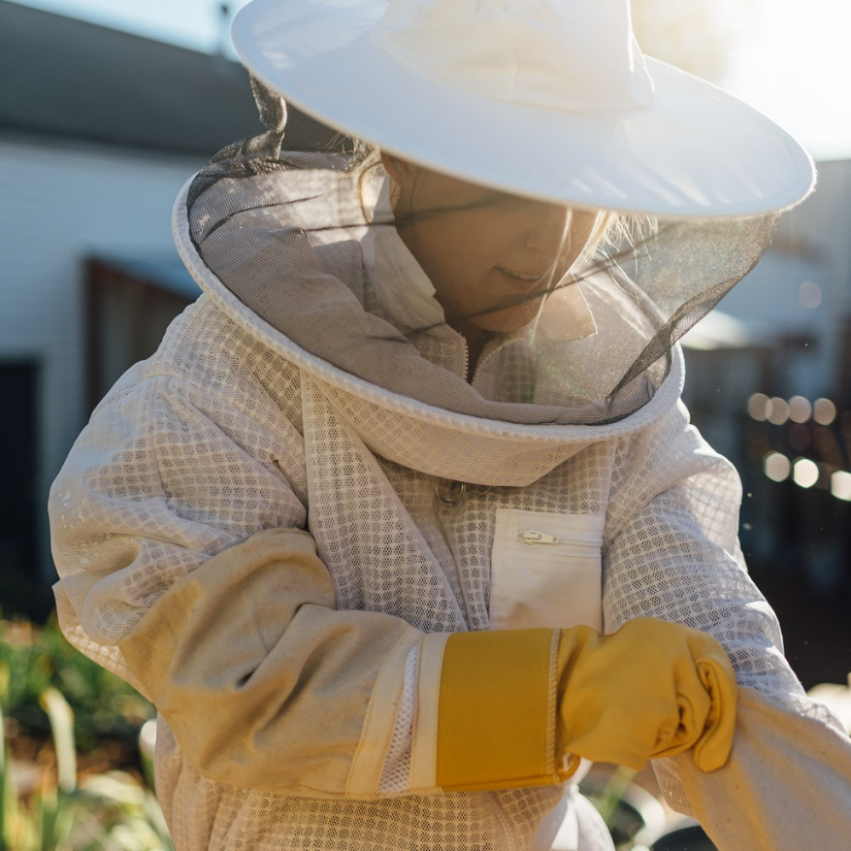

The Honey Bee Hive

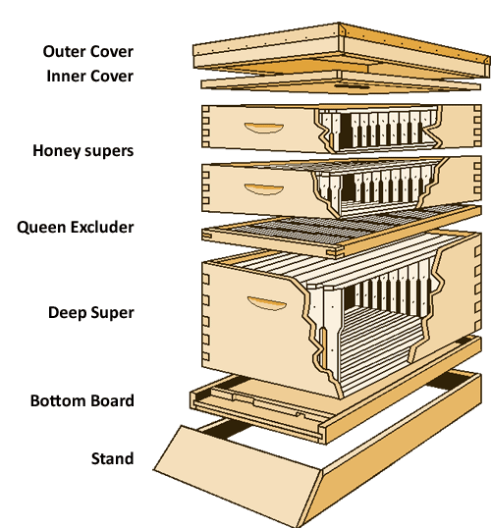

Honey Bee Frames

- Lots of bees
- Nice golden color (not gray!)
- Rainbow of honey on top surrounded by pollen
- Drone brood at the bottom
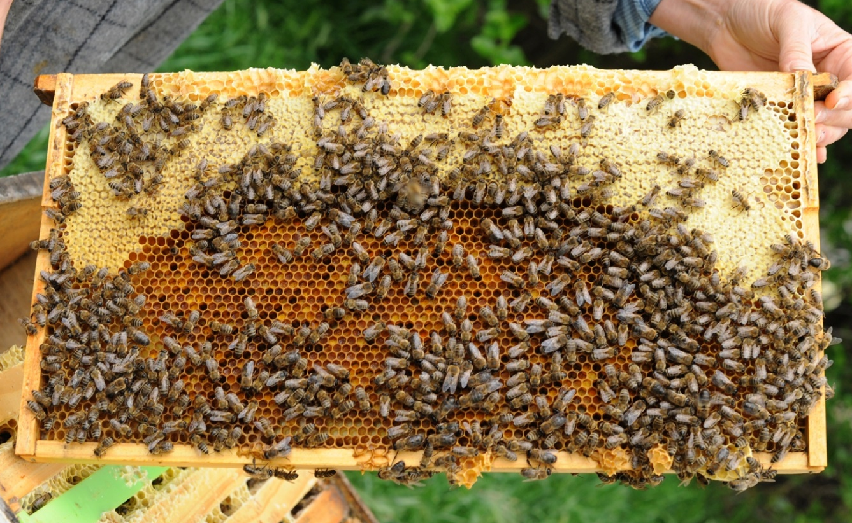
- Even distribution of capped cells

