Ferret 101
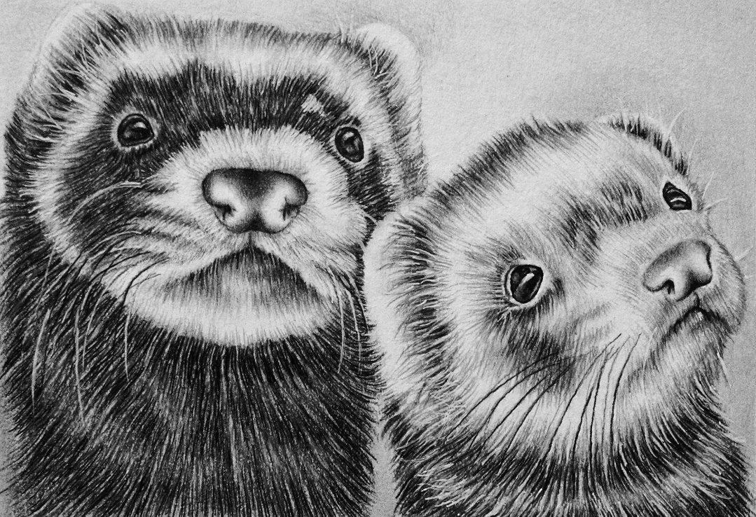
Ferret Characteristics

- 3rd most popular pet in America
- Domesticated from the European Pole Cat
- Member of the weasel family
- Considered an obligate carnivore
- Possesses a distinct musk odor
- Famous for their “war dance”
- Notorious thieves and hoarders

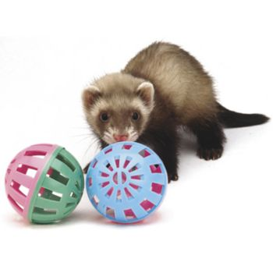
Ferret Basics

- Lifespan 5 to 8 years
- Weight 1.5 lb to 6 lb (depending on gender)
- Body temperature 100°F to 103°F
- Heart rate 180-250 beats per minute
- Respiratory rate 33-36 breaths per minute
- Sexually mature at 5 to 6 months of age
- Gestation period of 42 days
- Adult teeth appear at 47 days
- Choppers are full size at 70 days!

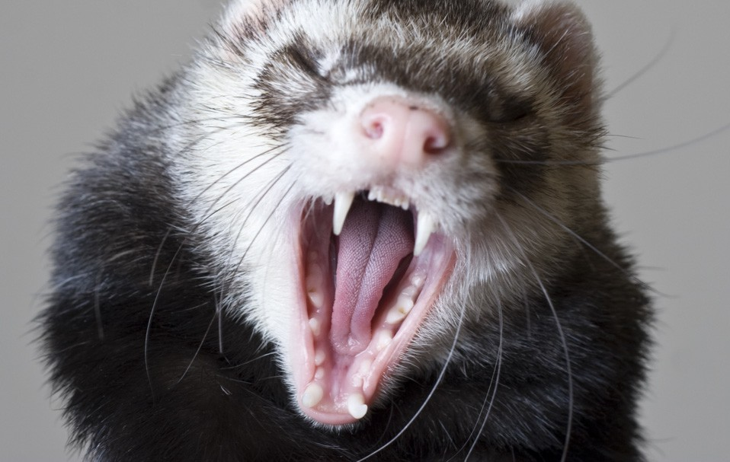

More Ferret Facts

- Intact females are “jills” and intact males are “hobs”
- Spayed females are called “sprites”
- Neutered males are called “gibs”
- Baby ferrets are called “kits”
- Female ferrets are induced ovulators
- Non-mated females in heat may die from estrogen-induced anemia
- Heat intolerant
- Very high metabolism- sleep up to 18 hours a day
- Naturally very itchy
- Very intelligent and explore constantly
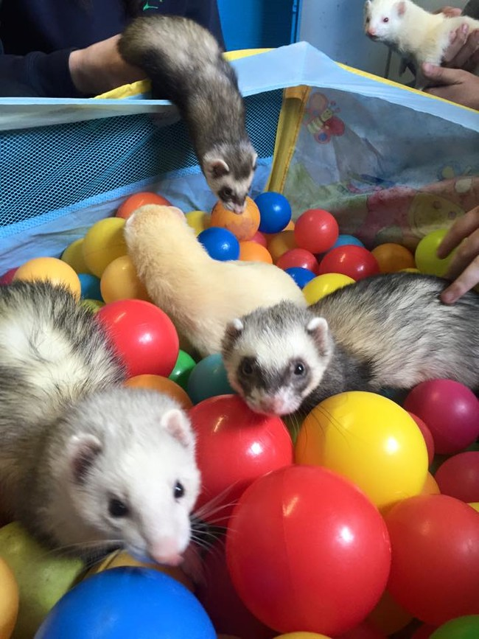
- Like to defecate in corners (latrine users)

Common Ferret Diseases

- Adrenal disease (adrenal gland tumor)
- Fur loss
- Weight loss
- Increased thirst
- Can treat with surgery or chemotherapy

- Insulinoma (cancer of the pancreas)
- Sudden loss of energy
- May appear intoxicated
- Blood glucose is suddenly low
- No cure, but can treat with steroids
- Steroids help release stored sugars

- Lymphoma (cancer of the white blood cells)
- Often no symptoms
- Lack of appetite and weight loss
- General lack of energy
- Treat with surgery or chemotherapy

Other Ferret Diseases

Epizootic Catarrhal Enteritis (ECE)
- Caused by a coronavirus shed in feces of carriers
- Destroys intestinal cells much like canine parvovirus
- Ferrets die of dehydration and malnutrition

Aleutian Disease (ferret parvovirus)
- Chronic wasting disease spread in body fluids
- Test blood of new ferrets and isolate

Canine Distemper
- Very contagious airborne virus
- Causes mucoid eye discharge, fever and death
- Vaccinate kits at 8, 11 and 14 weeks
- Vaccinate adults annually

Rabies
- Contagious zoonotic virus spread through saliva
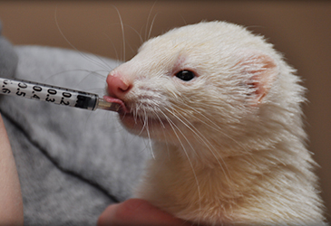
- Vaccinate kits at 12 weeks, then annually as adults*

Handling Ferrets

- Grasp by scruff initially to avoid bite

- Position one hand under the shoulders with a thumb under the jaw

- If neck is too thick, then holding by scruff is ok

- Position other hand to support the hindquarters
