Color wheel of poop

What can poop tell us?
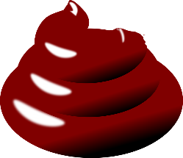
Size
The volume of a dog’s waste should be proportionate to the amount of food he consumes. Poop size increases as the fiber content in his food increases.
Consistency
Dog poop should be compact, moist and easy to pick up – yet feel like Play-Doh when squished. Diarrhea or watery feces can be an indication of intestinal upset.
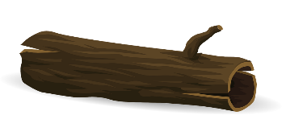
Color
Dog poop should be chocolate brown. Color in dog food may contribute to color of dog poop.
Shape
Dog stool should be shaped like logs and maintain their form. If droppings are round, the dog may be dehydrated.

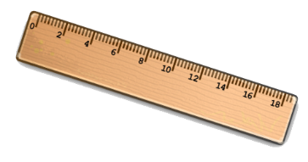
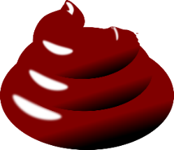

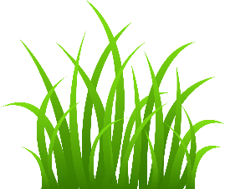

Content
Mucus in poop? Could be an indication of an inflamed colon. Excessive grass? Could indicated that he’s stressed or has gastric upset. If our dog has a dermatological problem and he’s losing hair or licking a lot, expect to see increased hair in his stool. Small white bits? Your dog may have tapeworms – time for the vet!

What does the color of poop mean?
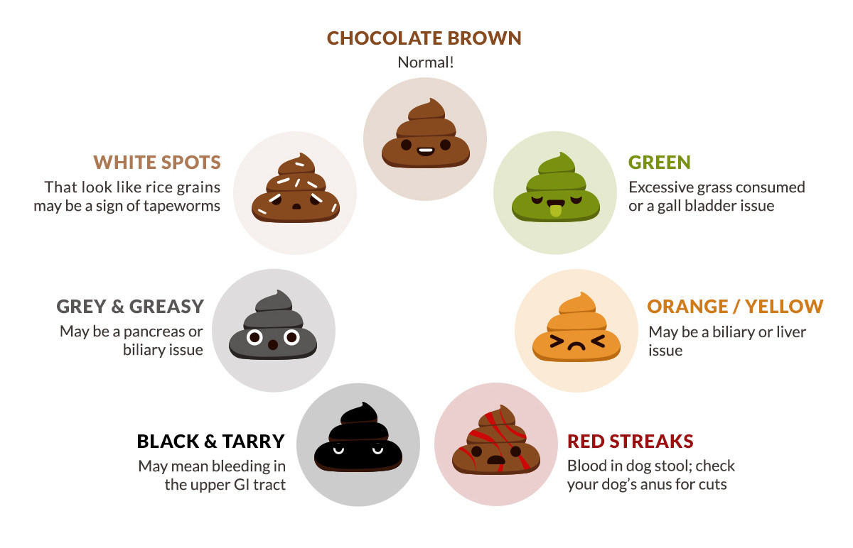

The Gastrointestinal Tract

- Food (ingesta) travels down the esophagus
- Ingesta enters the stomach to be broken down by acid
- Digesta moves through small intestines to be absorbed
- Digesta moves through colon to become feces
- Feces are stored in rectum
- Feces leave body through the anus (defecation)

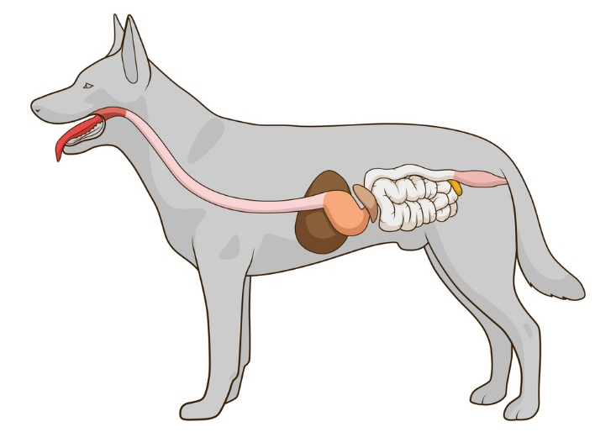
6.
5.
4.

1.
3.
2.

The Anal Glands

- Anal sacs expel pheromone during defecation
- Also called scent glands
- Secretion is used for animal identification (territory)
- Inflammation can block ducts
- Sacs can rupture if not expressed regularly!

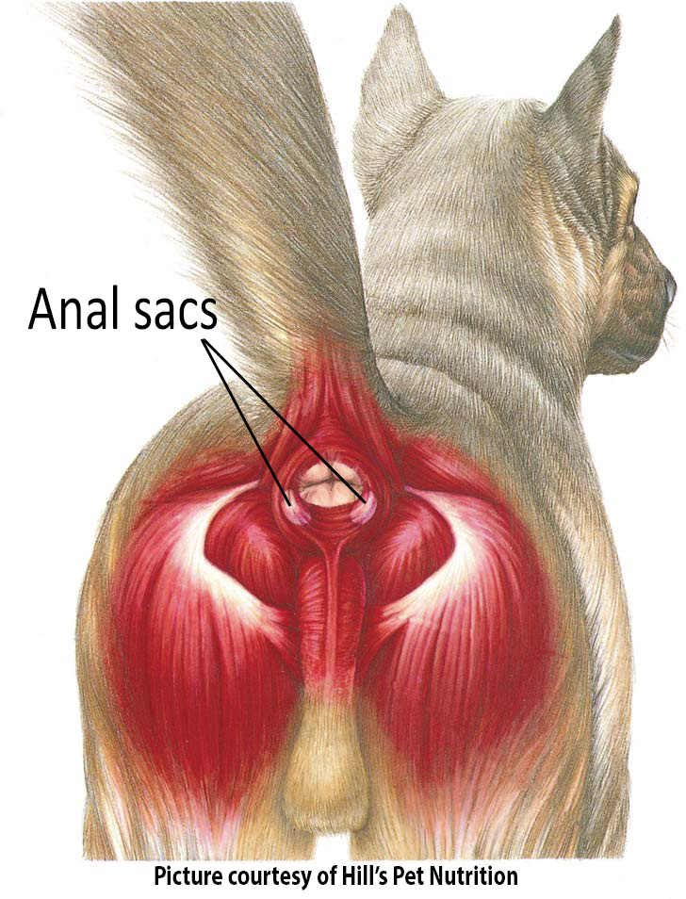
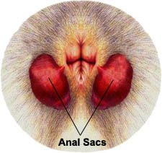

Types of Bacteria in Feces

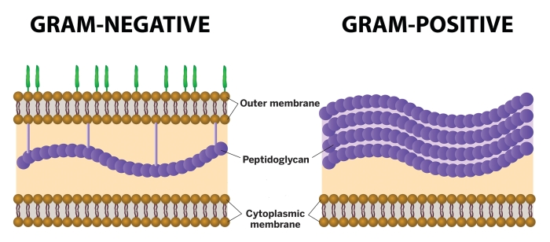

Gram-Positive bacteria in feces
Clostridia s
Enterococcus

Gram-Negative bacteria in feces
Campylobacter
Escheria coli
Salmonella
Proteus

The Gram Stain

