Fecal Egg Count

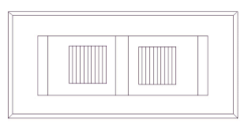

Why do we do fecal egg counts?

* Determine the worm burden of a given animal
* Determine the type of parasites present
* Determine if dewormer is working (efficacy)
* This lesson is for the Modified McMaster’s FEC

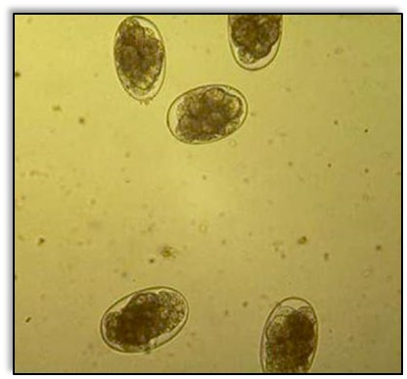

How do we prepare feces?

* Place cup on scale and measure 2 grams of feces
* Add 28 ml of sugar solution to feces and stir with stick
* Meanwhile, place cheesecloth over another cup
* Pour contents of first cup into the second cup
* Use stick to aid in moving liquid through cheesecloth
* Remove cheesecloth and discard
* Use plastic pipette to stir strained solution
* Draw up 1 ml of solution into pipette
* Tilt McMaster’s slide and use tip of pipette to add solution
* Fill both squares of McMaster’s slide
* Allow solution to sit in slide for 5 minutes before viewing

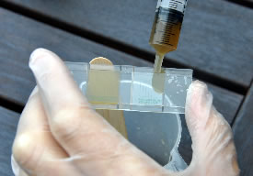

How do we count eggs in feces?

* Lower state of microscope to place McMaster’s slide
* Turn on microscope and adjust 100x objective
* Use course adjust to bring slide into focus
* Use fine adjust to specifically focus on bubbles
* *Haemonchus* eggs are on same plane as bubbles!
* Count each parasite egg in each column
* Count eggs on the grid line if > ½ of egg is inside grid
* Write down total # from all columns in both squares
* Multiply the total number of eggs by 50
* This number is the # of eggs per gram of feces

