Diff-Quik Stain Procedure
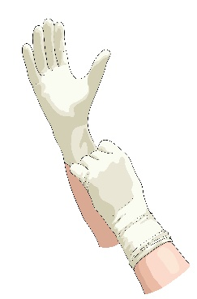
1. Put on gloves (unless you want pink and purple fingers!)

2. Use a clothespin to pick up microscope slide

3. Dip slide slowly 10 times in light blue fixative

4. Dip slide slowly 8 times in red stain

5. Dip slide slowly 8 times in purple counter stain

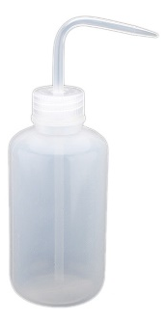

6. Gently rinse slide with distilled water

