Rashes and other itchy stuff

Structures of the skin

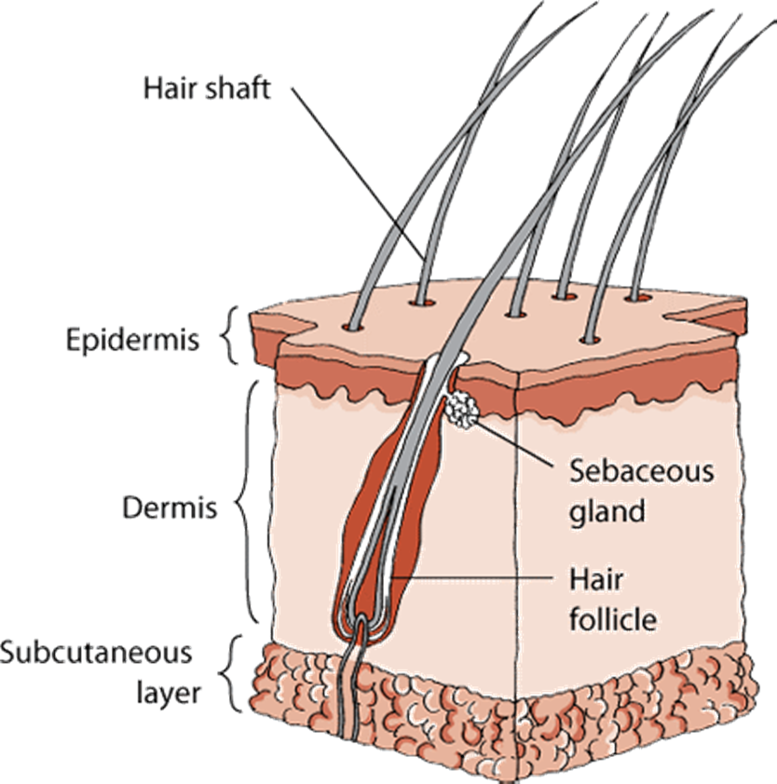

What is dermatitis?

- Dermatitis is inflammation of the skin
- Incited by allergies, infection, mites, hormones or medication
- Skin can become red, painful, itchy, crusty, flaky, oily or smelly
- Caused by a combination of several factors:
- Skin barrier dysfunction
- Cell mediated immune responses
- IgE mediated hypersensitivity
- Environmental factors

Dermatology terms

- Otitis externa –inflammation of the outer ear canal

- Atopic dermatitis – inflammation caused by allergens

- Pododermatitis – inflammation of paws

- Conjunctivitis – inflammation of eyelids

- Acute moist dermatitis – commonly known as hot spots

- Pyoderma – bacterial skin infection

- Dermatophytosis – fungal skin infection

- Demodicosis – inflammation caused by Demodex mite

- Flea allergy dermatitis – inflammation due to flea bites

Common skin problems

- Otitis Externa
- Acute moist dermatitis
- Atopic dermatitis
- Flea allergy dermatitis
- Pyoderma
- Demodicosis
- Dermatophytosis

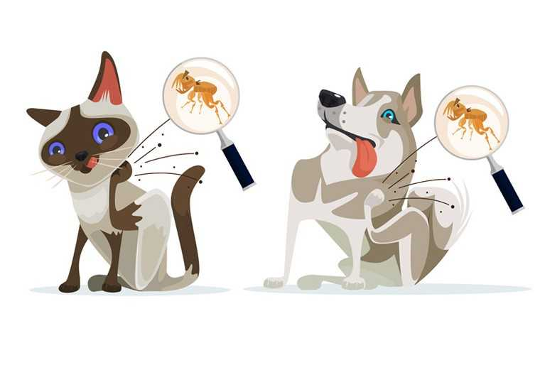
Otitis Externa

- More common with breeds that have long ears
- Animal is genetically predisposed to skin inflammation
- Ear mites can cause inflammation
- Bacterial and fungal infections are usually secondary
- Excess scratching can cause a hematoma
- Diagnosed by an ear swab and microscopy

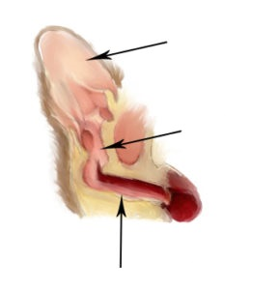
Ear flap
Vertical canal
Horizontal canal

Ear mites

- More common in cats – itchy and miserable
- Diagnosed by microscopy
- Mites are killed by a prescribed otic insecticide
- An otic anti-inflammatory is usually prescribed

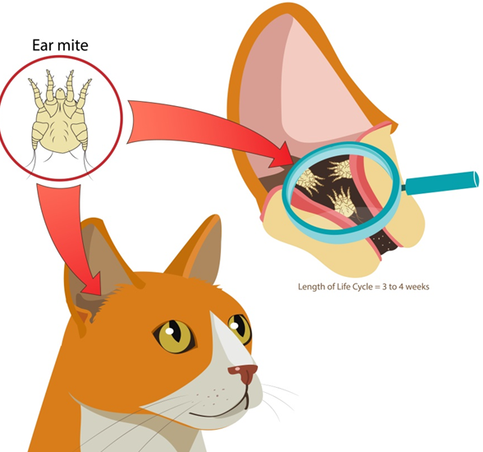

Ear infection

- Ears are itchy and/or painful
- Ear canal is red with yellowish, brown or black wax
- Yeast infection is most common
- Commensal bacteria can overgrow
- Pathogenic bacteria cause a true infection with pus
- Treated with an otic antibiotic-fungicide-steroid

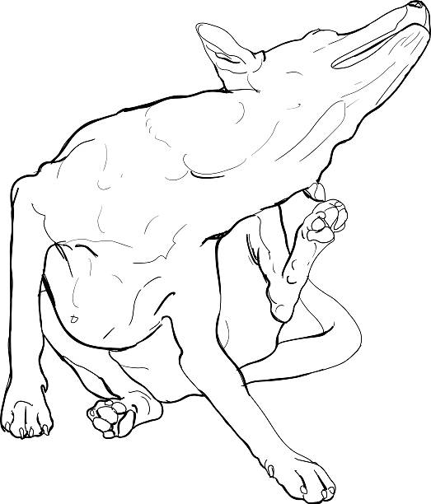

Acute moist dermatitis

- Cause is not fully understood
- Stimulated by licking, chewing or scratching
- Results in excess inflammation
- Skin is red, hot, painful and oozing
- Long haired breeds are more susceptible
- Steroids are usually needed to calm inflammation
- Secondary pyoderma may require antibiotics
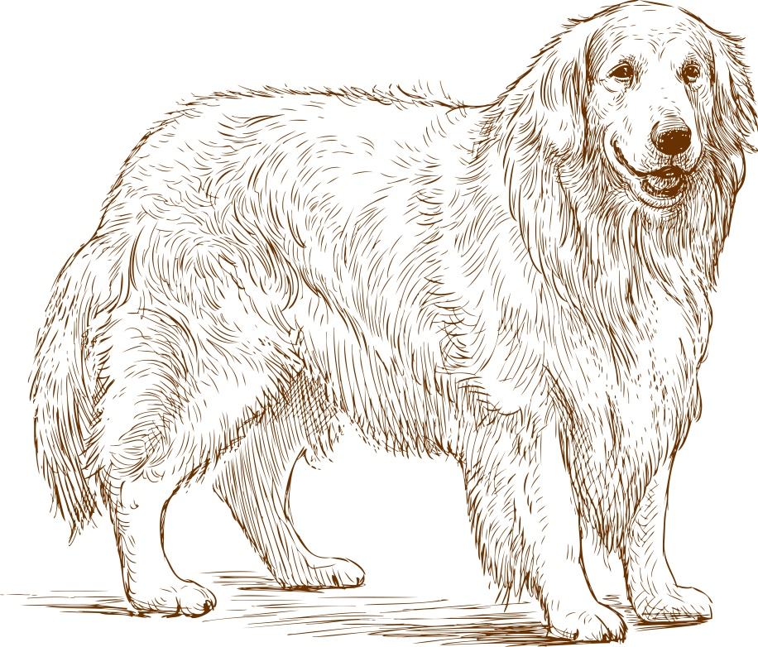

Atopic dermatitis

- Caused by a response to an allergen (topical or oral)
- Goals are to treat inflammation and itchiness
- Treated with anti-histamines +/- steroids
- New generation of anti-inflammatories available
- Control by bathing with skin replenishing shampoo
- Control by reducing allergens in environment
- Immunotherapy is an alternative

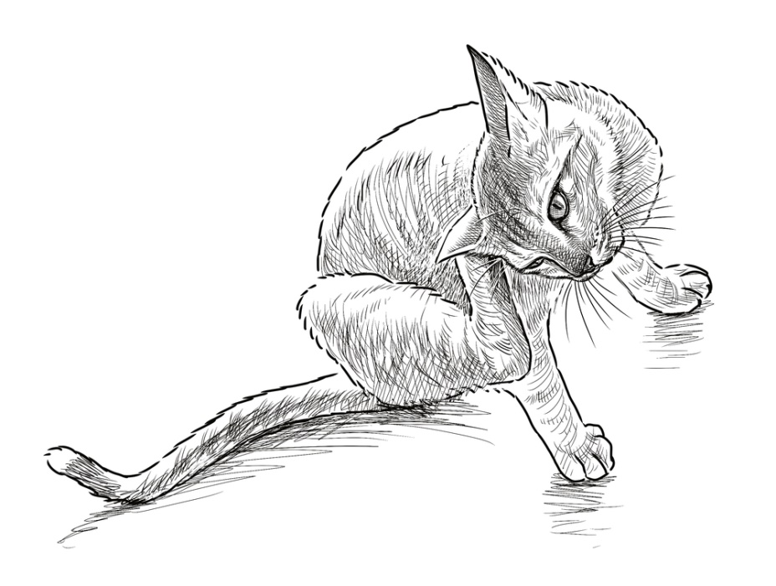

Flea allergy dermatitis

- Caused by a hypersensitivity to a flea bite
- A single bite can cause system-wide skin inflammation
- Steroids are usually prescribed for inflammation
- Fleas killed with topical or oral insecticide
- Secondary pyoderma is common
- Environment must also be treated

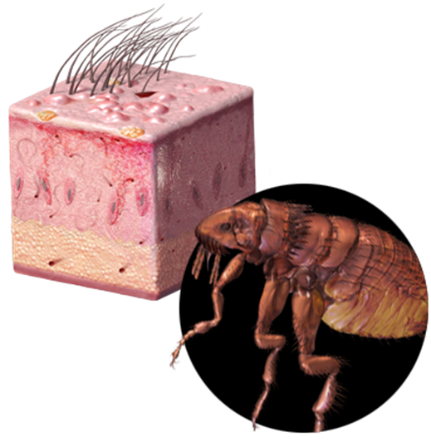
Pyoderma

- Often secondary to dermatitis
- Superficial and deep forms
- Often seen on abdomen of puppies
- Diagnosed by skin swab
- Staph infections are most common
- Treated with topical or oral antibiotics
- Controlled with bathing in antibacterial shampoo
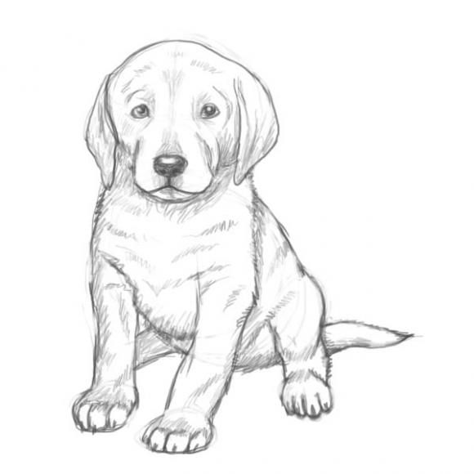

Demodicosis

- Caused by the Demodex mite
- Problem in immunocompromised animals
- Defective skin barrier lets mite cause inflammation
- Fur loss and thick, crusty skin are hallmark signs
- Secondary pyoderma is common
- Diagnosed by skin scrape and microscopy
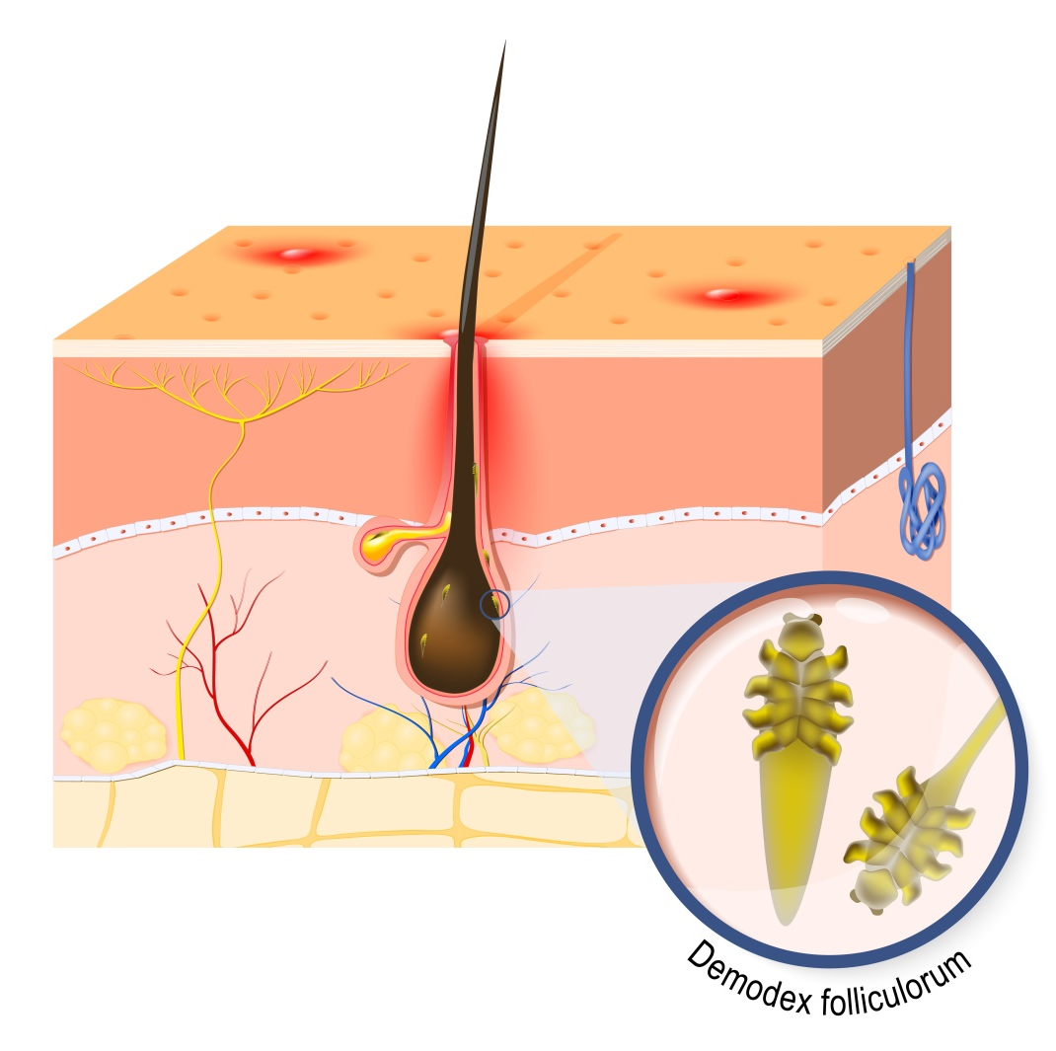
Dermatophytosis

- Also called ringworm, but is caused by a fungus
- Common in cats, but any animal can be infected
- Itchy, contagious and zoonotic!
- Lesion is round and red +/- dark edge
- Fur usually falls our around region
- Diagnosed by ultraviolet light or fungal culture
- Treat with oral or topical antifungal
- Remove spores from environment

Ear swab cytology

