Cattle Handling
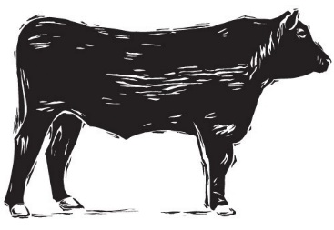
Where to get blood from cattle?
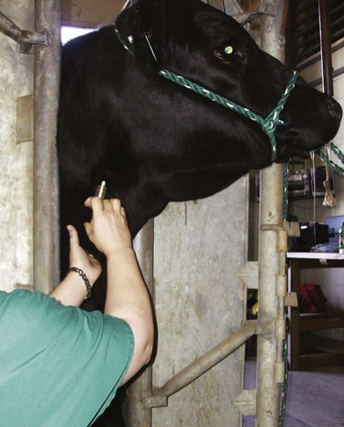
Jugular vein

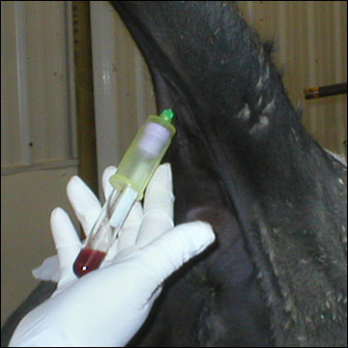
Tail vein

What are common cattle blood tests?

- Blood Cell Count
- Blood smear
- Blood Chemistry
- Genetic testing (for breeding)
- Pregnancy testing
- Bovine Viral Diarrhea Virus testing
- Johne’s disease testing

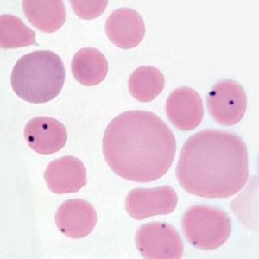
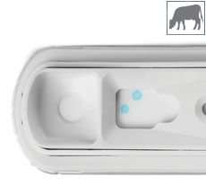
Tips for cattle venipuncture

- Ensure that animal is restrained properly
- Determine blood draw site and clean with alcohol
- Palpate vein prior to inserting needle
- If multiple tubes, use vacutainer needle
- It takes force to get needle through cow skin
- Bigger animal = more blood = more mess
