Cardiopulmonary Auscultation

Where to listen on left side?
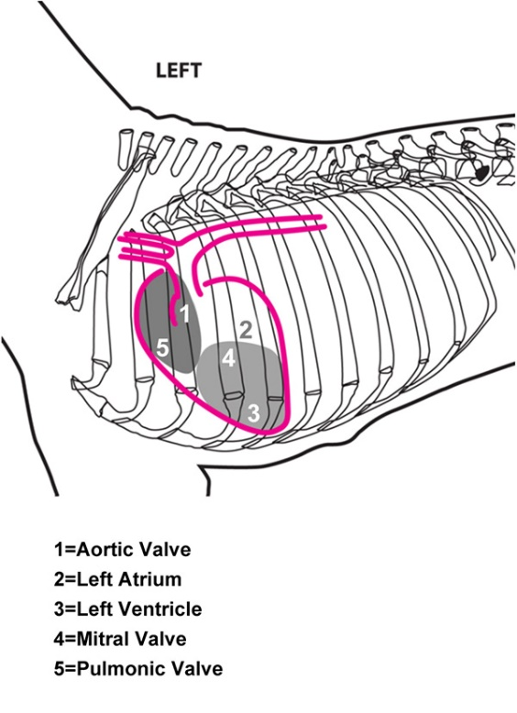
Where to listen on right side?

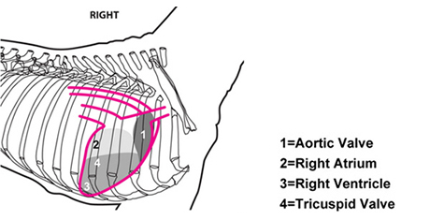
Where to listen?
P
A
M
Left Side
A
T
Right Side
How do you listen to lungs?

- Examine the respiratory movements to ensure that there are no abnormalities.

- Measure the respiratory rate of the dog (number of breaths over 15 seconds X 4). Normal respiration rate for a dog is 10-30 respirations/minute.

- Auscultate the tracheal bifurcation at the level of the mid-thorax (8th intercostal space). Ensure the mouth is closed to prevent panting sounds.

- Auscultate sounds of the thorax dorsally, ventrally, cranioventral, craniodorsal and caudodorsally, as well as the trachea and larynx.

- By auscultating the upper and lower respiratory tract, the abnormal breath sounds can be localised.
Resting Heart and Breathing Rates

Species | Beats/min | Breaths/min
Human | 60-100 | 12-20
Dog | 70–120 | 10-30
Cat | 120–140 | 16-40
Horse | 28–40 | 10–14
Dairy Cow | 48–84 | 26-50
Sheep | 70–80 | 16–34
Pig | 70–120 | 32–58
Ferret | 180-250 | 33-36
Rabbit | 120-150 | 30-60
Guinea Pig | 200–300 | 42-105
Mouse | 450–750 | 80-230

*Always evaluate by rate, character and position for both cardio and respiratory auscultation!
Heart Abnormalities

- Atrial fibrillation - rapid and irregular beat

- Mitral regurgitation - whoosh sound caused by backward flow of blood through faulty mitral valve

- Mitral valve click - sharp whoosh sound caused by a prolapsed mitral valve being pulled back suddenly by the chordae tendineae

- Patent Ductus Arteriosus (PDA) – constant whoosh sound caused by blood from a persistent fetal blood vessel moving blood from the aorta to pulmonary artery

- Pulmonic stenosis - extra sound caused by obstruction of flow from the right ventricle of the heart to the pulmonary artery

- Subaortic stenosis (SAS) - whoosh sound caused by the flow of blood from the left ventricle being restricted under the aortic valve

- Ventricular Septal Defect (VSD) – whoosh on second heart sound caused by turbulent flow into the left ventricle from the left atrium
Respiratory Abnormalities

- Wheeze – course whistling sound that varies in pitch and caused by narrowing of airway anywhere from the trachea to lungs.

- Monophonic wheeze – same as above, but the sound has the same pitch when breathing in and out

- Pleural friction rub- clicking sound caused by layers of the inflamed pleural membrane rubbing against each other

- Stridor - a high pitched vibrating noise caused by obstruction of the trachea or larynx

- Stertor - heavy snoring or gasping heard on inspiration

- Crackles – popping or crackling sounds heard on inspiration caused by a buildup of fluid, mucus or pus in the small airways

- Pulmonary edema – gurgling or crackling sound heard at the end of inspiration caused by fluid accumulation in the tissue and air spaces of the lungs

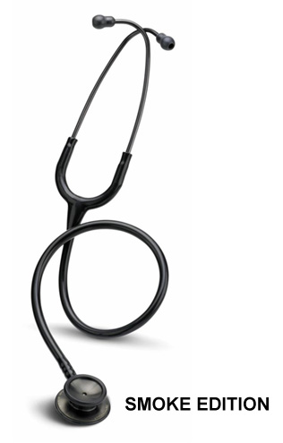
The Stethoscope
Earpiece
Binaural piece
(Ear tubing)
Flexible tubing
Chest piece
(diaphragm)
Stem

Earpiece Placement

