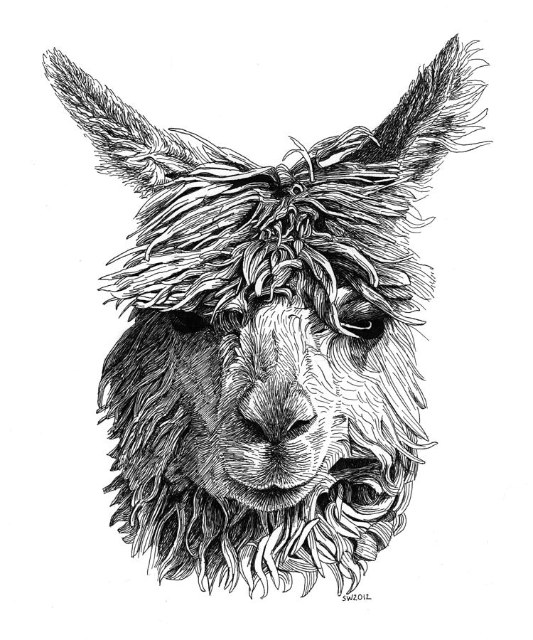
Camelids

Camelid 101

- Camelids are large, strictly herbivorous animals
- Includes camels, llamas and alpacas
- Strict herbivores
- Camelids differ from ruminants
- They have true canine teeth and tusk-like premolars
- Different hindlimb musculature
- They have a 3 chambered stomach (no reticulum)
- They have a prehensile upper lip
- Their red blood cells are elliptical
- They have unique heavy chain antibodies

Llamas

- Scientific name is Lama glama
- Average height is 5.6 to 5.9 ft
- Average weight is 290 and 440 lb
- A baby llama is called a cria
- Llamas typically live for 15 to 25 years
- Females are induced ovulators
- The gestation period of a llama is 11.5 months
- Male llamas are excellent livestock guard animals
Llama vital signs
- Normal rectal temperature 99.0° to 101.5°F
- Average heart rate is 48 to 60 beats per minute
- Average breathing rate is 12 to 30 breaths per minute

Alpaca

- Scientific name is Vicugna pacos
- Average height is 2.7 to 3.2 ft
- Average weight is 110 to190 lb
- A baby alpaca is also called a cria
- Alpacas typically live for 15 to 20 years
- Females are also induced ovulators
- The gestation period of an alpaca is 11.5 months
- Alpacas are social animals that live in groups

Alpaca Vital signs
- Normal rectal temperature 99.5° to 102.5°F
- Average heart rate is 70 to120 beats per minute
- Average breathing rate is 6 to 20 breaths per minute

Differences between camelids

Their ears: Alpaca ears have short spear-shaped ears while llamas have much longer, banana-shaped ears.
Their size: Alpacas generally weigh in at around 150 pounds while llamas can get as heavy as 400 pounds. At the shoulder, an average alpaca stands between 34 and 36 inches, while a llama generally ranges between 42 and 46 inches.
Their faces: Llamas have a longer face; an alpaca’s face is a bit blunter, giving them a “smooshed in” look.
Their purpose: For more than 5,000 years alpacas have been bred for fiber (and in Peru for meat as well), while llamas have been bred for the same amount of time as pack animals and meat.
Their hair: The alpaca produces a much finer fiber than the llama. The alpaca also produces more fleece than its larger cousin and in a much greater variety of colors. Llamas also generally do not have as much hair on their head and face as alpacas do.
Their dispositions: Alpacas are very much herd animals, while llamas are more independent minded. Alpacas also tend to be a bit more skittish than llamas, which are often used as guard animals for alpacas, sheep, and other small livestock.

