Blood Smear
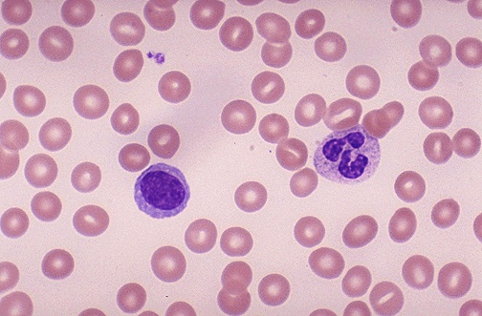
What is a blood smear?

- A blood smear is a blood test used to look for abnormalities in blood cells

- The three main blood cells that the test focuses on are red cells, which carry oxygen throughout the body, white cells, which help the body fight infections and platelets, which are important for blood clotting

- An ideal blood smear has an even distribution with a feathered edge and a thin monolayer (zone of morphology)

- The feathered edge will contain larger white blood cells and platelet clump

How do you make a blood smear?

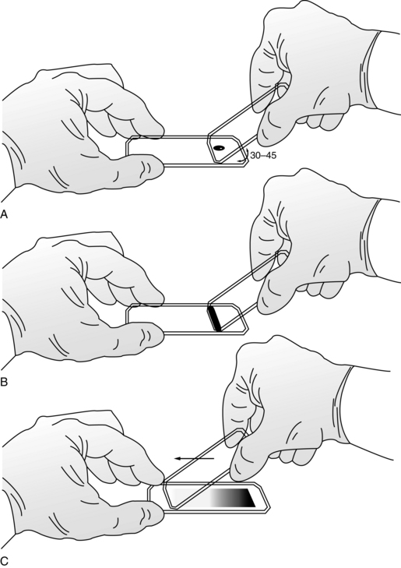

What does a good slide look like?

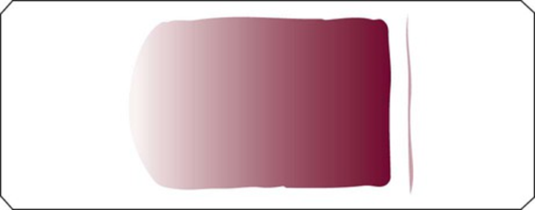
Body
Monolayer
Feathered edge

What does a bad slide look like?
