Blood Cytology
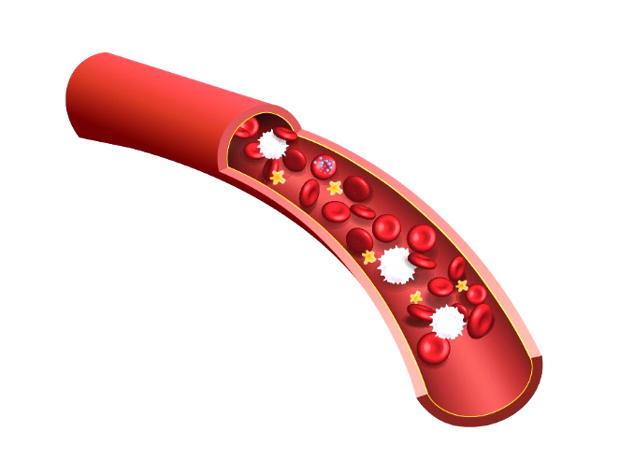
What is blood cytology?

- The study of the microscopic appearance of cells, especially for the diagnosis of abnormalities and malignancies

- Each cell type has unique characteristics

- Veterinarians are trained to know these special characteristics

- Abnormalities of cells may indicate a disease process

- Too few cells may indicate anemia

- Too many cells may indicate inflammation or malignancy

What cells are normally in blood?

What do these cells do?

- Erythrocytes (blood cells) carry oxygen to tissues

- Platelets are tiny cells that have a big job in stopping bleeding

- Monocytes fight infections and help other white blood cells remove dead or damaged tissues, destroy cancer cells, and regulate immunity against foreign substances

- Eosinophils are implicated in numerous inflammatory processes, especially allergic disorders

- Basophils contain anticoagulant heparin, which prevents blood from clotting too quickly. They also contain the vasodilator histamine, which promotes blood flow to tissues

- Neutrophils are the first cells to migrate to the site of infection to begin killing the invading microbes

- Lymphocytes eliminate pathogens by releasing antibodies, releasing cytotoxic granules or signaling to other cells of the immune system
Blood cell abnormalities

- Spherocytes form when parts of the cell membrane are damaged (auto-immune disease)

- Target cells form due to an excess in cell membrane (liver disease)

- Acanthocytes have uneven thorny outer membranes caused by a defect in the lipid or protein composition of the membrane (liver disease and many others)

- Echinocytes look similar to acanthocytes but have uniform spikes covering the entire cell surface. They are usually an artifact due to chemical treatment of the slide

- Schistocytes are pieces of shredded red blood cells that signal active red blood cell destruction by the body (very bad!)
Other abnormalities

- Platelet clumps often occur in cats. Always check the feathered edge of the smear!

- Neutrophils with a sausage-looking nucleus are called “banded” and signal an active inflammatory process

- Neutrophils that look bubbly inside are called “toxic” and signal a blood infection

- Over-representation of any cell that is not a red blood cell or platelet signals a potential neoplasia, especially if they are in clusters

- White blood cells that vary drastically in size or have unusual nuclei signal a potential neoplasia

- Visual mitotic bodies are definitive of neoplasia

DiffQuik Stain Procedure

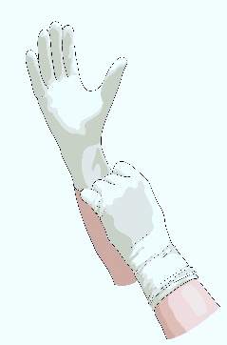
Put on gloves (or have blue/pink fingers)

Pick up slide with clothespin

Dip slide slowly 5 times in light blue fixative

Dip slide slowly 5 times in dark pink stain

Dip slide slowly 5 times in purple counter stain

Gently rinse slide with distilled water

Allow to air dry before viewing

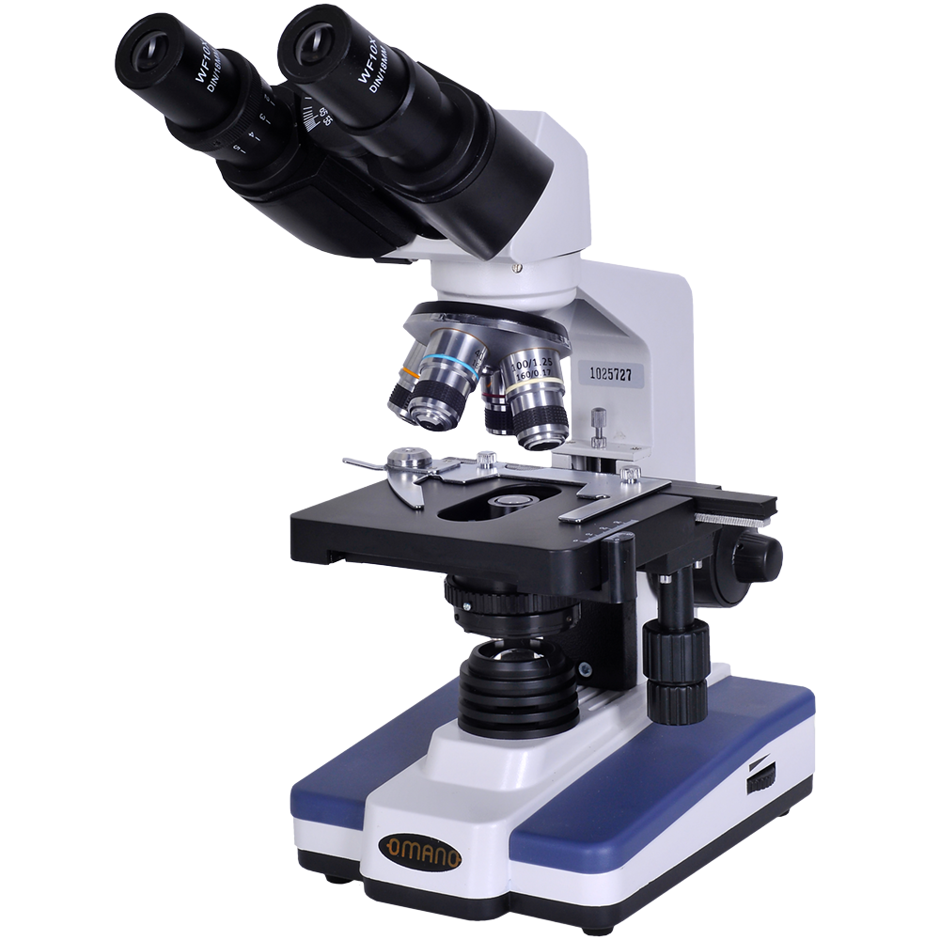
The Compound Microscope

