Bandaging

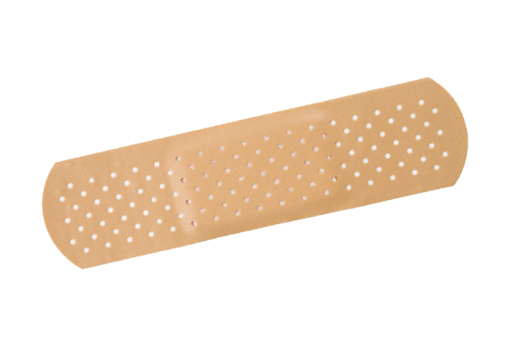
Why do we bandage wounds?

- Ease pain
- Prevent contamination
- Keep pet from licking
Do all wounds need a bandage?

Do bandage if:
- Much skin is missing
- Wound is deep

Do not bandage if:
- Abrasion
- Puncture wound
Most common wounds for dogs are:
- Broken claws
- Paw pad wounds

Parts of the Dog Paw

How do we bandage a paw wound?
Carpal pad
Metacarpal pad
Digital Pad
Claw
Dew claw
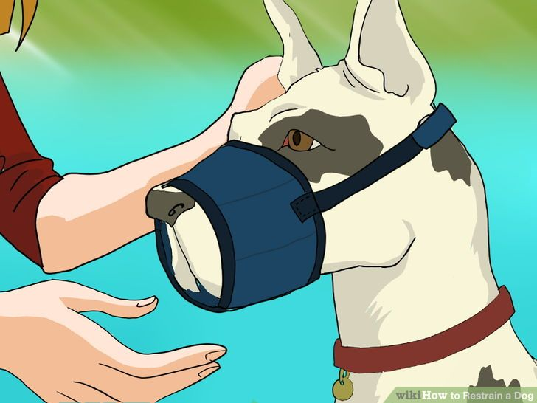
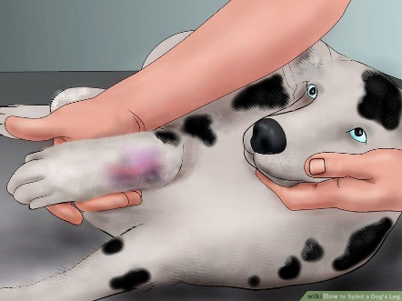
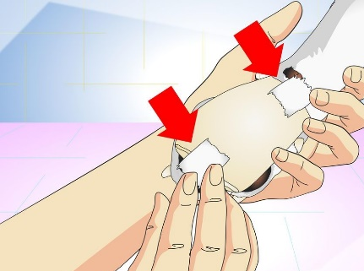
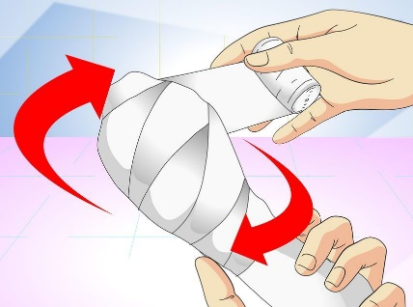
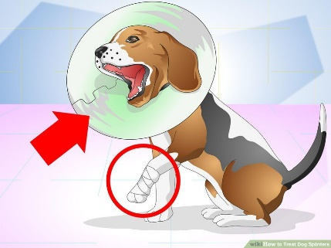
1. Apply muzzle
2. Lay pet on side
3. Apply sterile jelly to wound
4. Clip fur around wound
5. Clean wound with antiseptic
5. Flush wound with sterile saline
6. Dry wound with sterile gauze
7. Place non-stick pad on wound
8. Wrap cotton around wound
9. Apply gauze over cotton
10. Apply vet wrap over gauze
11. Place tape to secure bandage
12. Place a collar on neck

