Anesthesia

Circle Breathing Circuit
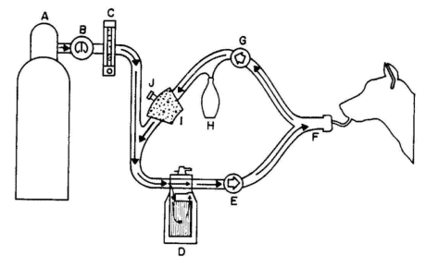

Circle Breathing Circuit

A.
B.
C.
D.
E.
F.
G.
H.
I.
J.

Important Numbers

- Reservoir bag based on 10-15 ml/kg
- Oxygen flow based on 25-50 ml/kg/min
- Fluid rate 10-20 ml/kg/hr
- To get kg, divide lb by 2.2
- A 40 pound dog weighs 18 kilograms
- Dog vital signs
- Heart rate is 60-140 beats per minute
- Breathing rate is 12-24 breaths per minute
- Body temperature is 100.5-102.5°F
- Normal mean blood pressure is 100 mm Hg
- Cat vital signs
- Heart rate is 160-240 beats per minute
- Breathing rate is 20-30 breaths per minute
- Body temperature is 100.5-102.5°F
- Normal mean blood pressure is 135 mm Hg
- Horse vital signs
- Heart rate is 30-40 beats per minute
- Breathing rate is 8-15 breaths per minute
- Body temp is 99-100.5°F
- Normal mean blood pressure is 90 mm Hg

