Principles of acupuncture

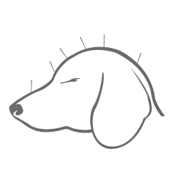

What is acupuncture?

- Points on skin surface connect to nerves
- Needles are inserted into skin to stimulate nerves
- Procedure is performed to create a healing response
- Considered alternative or holistic medicine
- Contact points have specific actions when stimulated
- Can be used with or without electric current
- Alieves symptoms of several diseases and disorders
- Needles are painless to the patient
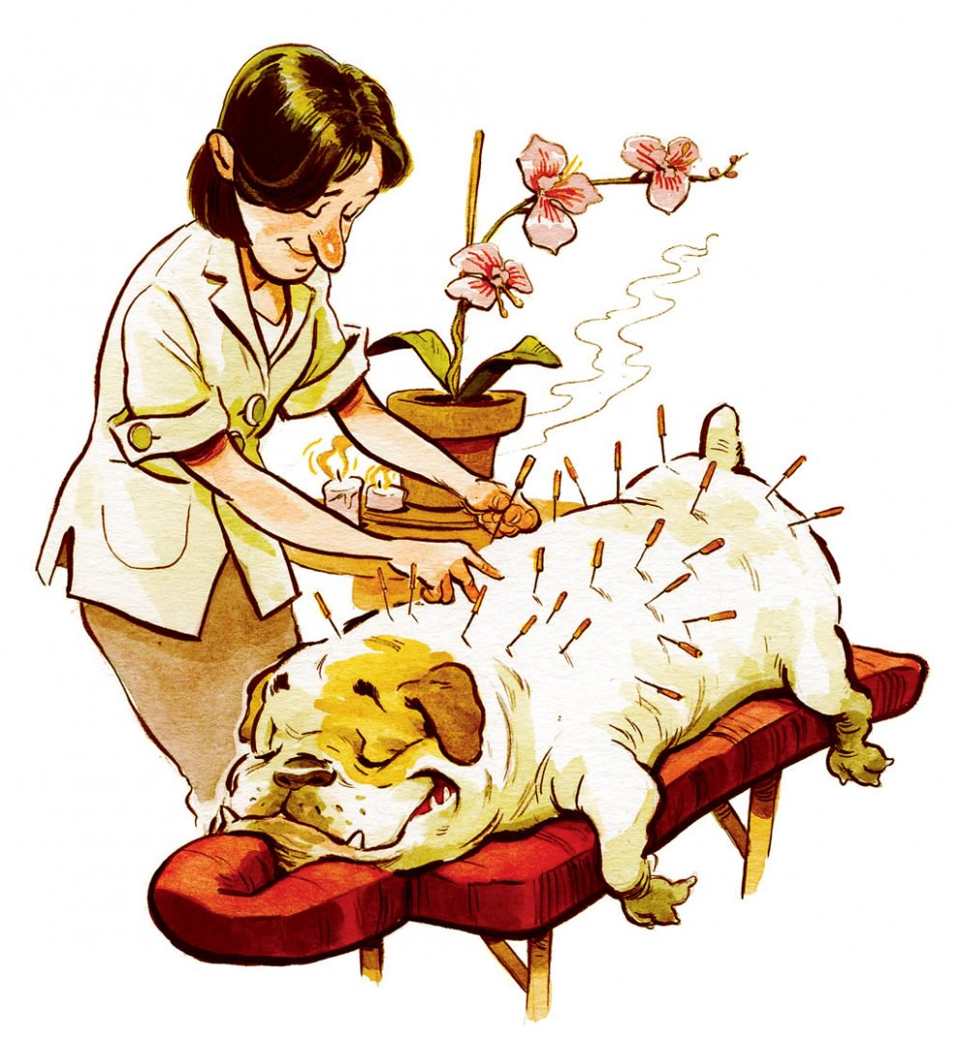

Is acupuncture scientific?

- Acupuncture points confirmed by functional MRI
- Inhibits COX-2 and NK-1 pathways that cause pain
- These pathways also cause inflammation
- Most studied in dogs with intervertebral disc disease
- Noticeable reduction of pain
- Noticeable improvement in paralysis

Acupuncture points small animals
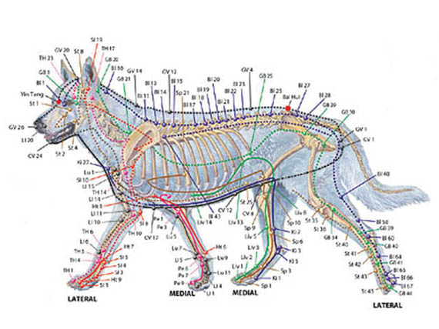

Acupuncture points in the horse

