CONTEST SECTIONS

- Livestock Breed Identification: (40 points) Identify from photographs 20 livestock (beef cattle, swine, sheep, and goat) breeds.
  - Junior Breed ID: (20 points) Juniors will only identify 10 livestock breeds.

- Livestock Equipment Identification: (40 points) Identify the proper name for 20 pieces of equipment used in livestock production. (A list of equipment will be provided.)
  - Junior Equipment ID: (20 points) Juniors will only identify 10 pieces of equipment.

- Retail Meat Cut Identification: (40 points) Identify 10 beef, lamb, and/or pork retail cuts from the National 4-H Meat Judging Retail ID List. Contestants will identify the cut by species, primal cut, and retail cut name. One point will be awarded for correct species, one point will be awarded for correct primal cut, and two points will be awarded for correct retail cut.
  - Junior Retail Meat Cut ID: (20 points) Juniors will only identify species and retail cut name for the 10 cuts.

- Livestock Feed Identification: (30 points) Identify the proper name for 15 livestock feeds.
  - Junior Feed ID: (20 points) Juniors will only identify 10 feeds.

- Livestock Plants Identification: (30 points) Identify the common name for 15 plants. This will include common Arkansas forages and forbs and be a multiple choice format.
  - Junior Plant ID: (20 points) Juniors will only identify 10 plants.

- Quiz: (60 points) Complete a 30-question multiple choice quiz concerning the primary livestock industries (cattle, swine, sheep, goats). This portion will include identifying components of a drug label and common livestock vocabulary.
  - Junior Quiz: (40 points) Juniors will have a simplified 20-question quiz.

Total possible points for senior 4-H’ers: 240 points
Total possible points for junior 4-H’ers (District only): 140 points

Scantron: https://www.judgingcard.com/ScanSheets/samples/UnivD-VA-Skillathon.pdf
Livestock Breed Identification List

The list below includes potential breeds of livestock to be used in the contest.

Beef Cattle
- Angus
- Beefmaster
- Belgian Blue
- Braford
- Brahman
- Brangus
- Charolais
- Chianina
- Dexter
- Gelbvieh
- Hereford
- Limousin
- Maine Anjou
- Piedmontese
- Pinzgauer
- Red Angus
- Salers
- Santa Gertrudis
- Shorthorn
- Simmental
- Wagyu
- White Park

Goat Breeds
- Alpine
- Angora
- Cashmere
- Boer
- Kiko
- LaMancha
- Myotonic
- Nigerian Dwarf
- Nubian
- Pygmy
- Saanen
- Savanna
- Spanish
- Toggenburg
Sheep Breeds
- Barbados Blackbelly
- Border Leicester
- Cheviot
- Columbia
- Corriedale
- Dorper
- Dorset
- Finnsheep
- Hampshire
- Katahdin
- Lincoln
- Merino
- Montadale
- Oxford
- Rambouillet
- Romney
- Shropshire
- Southdown
- Suffolk
- Texel
- Tunis
- Valais Blacknose

Swine Breeds
- Berkshire
- Chester White
- Duroc
- Hampshire
- Hereford
- Landrace
- Mangalista
- Meishan
- Mulefoot
- Pietrain
- Poland China
- Red Wattle
- Spot
- Tamworth
- Yorkshire

Additional Resources:
Oklahoma State University Livestock Breed Pictures and Descriptions: https://breeds.okstate.edu/

Livestock Equipment Identification List

The list below includes potential pieces of equipment to be used in the contest.

- Cattle Clippers
- Balling Gun
- Branding Iron
- Buhner Needle
- Implant Gun
- OB Chain & Handle
- OB Snare
- AI Gun
- Barnes Dehorner
- Electric Dehorner/Disbudder
- Tube Dehorner
- Scrotal Circumference Tape
- Ear Notcher
- Nose Lead
- Electric Fence Tester
- Drench Gun
- Hoof Trimmers
- Elastrator
- Elastrator Ring/Band
- Burdizzo
- California Castration Bander
- Ear Tag Pliers
- Ear Tags
- Electronic ID Tag
- Hog Snare
- Marking Harness
- Pig Tooth Nippers
- Hog Ring Pliers
- Nipple Waterer
- Scotch Comb
- Sorting Paddle
- Sorting Boards
- Tattoo Pliers & Tattoo Numbers
- Multi-Dose Syringe
- Ewe Prolapse Retainer/Ewe Spoon
- Disposable Syringes
- Emasculator
- Lamb Feeding Tube
- Wool Card
- Heat Detection Patch
- Beef Cattle Frame Stick
- Show Stick
- Straw Cutter
- Hoof Block
- Teat Canula
- Electronic Identification Reader
- CIDR (Cattle & Sheep)
- CIDR Applicator
- Ear Tag Remover
- AI Sheath
- Semen Straw
- Semen Bottle
- Weigh Tape
- Pelvimeter
- Rectal Ring
- Rope Halter
- Scalpel
- Hay Probe
- Vacutainer Blood Tube
- Hanging Vaccine Holder
- Meat Hook
- Node Hook
- Calf Weaning Nose Clip
- Trocar
- Chin-Ball Marker
- Goat Blanket
- Livestock Chalk
- Vet Wrap
- Rice Root Brush
- Ink Tag Marker
- Hand Shears
- Soil Probe
- Rumen Magnet
- Transfer Needle

Additional Resources:
University of Kentucky Equipment Identification Pictures http://afs.ca.uky.edu/livestock/feedstuff-equipment/livestock-equipment-identification
Feed Identification List

The list below includes potential feeds to be used in the contest.

- Rice Bran

- Distillers Dried Grains
- Cottonseed Meal
- Cracked/Chopped Corn
- Limestone
- Gin Trash
- Cottonseed Hulls
- Soybean Meal
- Soybeans
- Trace Mineralized Salt
- Wheat
- White Salt
- Whole Corn
- Molasses
- Grain Sorghum (Milo)
- Hominy
- Wheat Midds (Middlings)
- Oats (Crimped)
- Oats
- Rice (Rough Rice)
- Cottonseed
- Alfalfa Pellets
- Dicalcium Phosphate
- Fish Meal
- Corn Gluten Meal
- Ground Corn
- Dried Brewer’s Grains
- Poultry Litter
- Beet Pulp
- Barley
- Blood Meal
- Bone Meal
- Soybean Hulls
- Urea

Additional Resources:
UADA Feed Kit

University of Kentucky Livestock Discovery - Feedstuffs https://afs.ca.uky.edu/livestock/test/feedstuffs

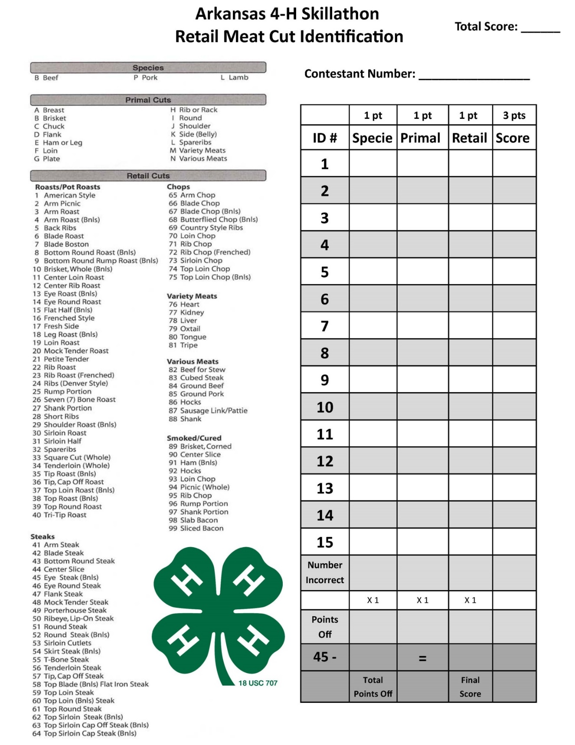
Additional Resources:
Texas A&M University Meat Identification Pictures http://aggiemeat.tamu.edu/meat-identification-pictures/
Texas Tech University Retail Identification http://www.depts.ttu.edu/meatscience/retailid.php
University of Nebraska Meat Identification https://food.unl.edu/meat-cuts-identification
Plant Identification List – Modified Grassland Evaluation Plant List

**GRASES AND GRASS-LIKE**
- Barley, Little
- Barnyard Grass
- Bermuda Grass
- Bluegrass (Kentucky)
- Bluestem, Big
- Bluestem, Little
- Bromegrass, Smooth
- Broomsedge (Broomstraw)
- Crabgrass
- Downy Chess (Downy Brome, Cheat Grass)
- Eastern Gamagrass
- Fall Panicum
- Fescue (Tall)
- Indiangrass
- Johnsongrass
- Orchardgrass
- Purple Top
- Ryegrass
- Sedges
- Switchgrass
- Timothy

**WOODY PLANTS**
- Blackberry/Dewberry
- Black Cherry
- Coralberry (Buckbrush)
- Dogwood
- Elm
- Grape
- Greenbriar
- Hickory
- Honeysuckle (Bush or Japanese)
- Locust (Black or Honey)
- Oak, Black or White
- Persimmon
- Poison Ivy
- Red Cedar (Juniper)
- Rose (Multiflora or Wild)
- Sumac
- Walnut

**FORBS**
- Bull Nettle (Horse)
- Chicory
- Cinquefoil
- Cocklebur, Common
- Curly Dock
- Croton
- Daisy Fleabane
- Dandelion
- Hemp Dogbane
- Horseweed
- Goldenrod (Prairie)
- Ironweed
- Milkweed, Common
- Mullein
- Perilla Mint
- Pigweed
- Plantain
- Poison Hemlock
- Pokeweed
- Queen Anne’s Lace
- Ragweed (Common, Giant, Lanceleaf)
- Red Sorrel
- Smartweed
- Spotted Knapweed
- Thistle (Tall, Musk, Bull)
- Three-seeded Mercury
- Yellow Wood Sorrel

**LEGUMES**
- Alfalfa
- Birdsfoot Trefoil
- Clover, White
- Clover, Red
- Clover, Little Hop
- Lespedeza (Korean, Common)
- Lespedeza, Sericea
- Partridge Pea
- Tick Trefoil (Beggar Tick)
- Vetch (Common, Hairy)
Grassland Evaluation Study Guide: https://4h.uada.edu/programs/plant-animal/Grassland%20Study%20Guide%2015th%20Edition_08.2023.pdf
Additional Livestock ID Resources

University of Illinois Livestock eQuiz
http://web.extension.illinois.edu/equiz/
Iowa State University “Animal U”
https://www.extension.iastate.edu/animalu/
Cornell Cooperative Extension General Livestock Sample Questions
http://ulster.cce.cornell.edu/resources/livestock-skillathon-quiz-bowl-questions
Ohio 4-H Livestock Activity Guide
https://ohio4h.org/sites/ohio4h/files/d6/files/publications/documents/4H_959_Chapter_2.pdf
National Swine Registry Skillathon Quiz Resources
https://nationalswine.com/resources/resources-main.php
Pork Checkoff Skill-a-thon and Quiz Bowl materials
https://lms.pork.org/Tools/View/skillathon-quiz-bowl
UADA Sheep and Goat Production Resources
https://www.uaex.uada.edu/farm-ranch/animals-forages/sheep-goats/
Beef Quality Assurance training manuals
https://www.bqa.org/resources/manuals

