FY-H-800

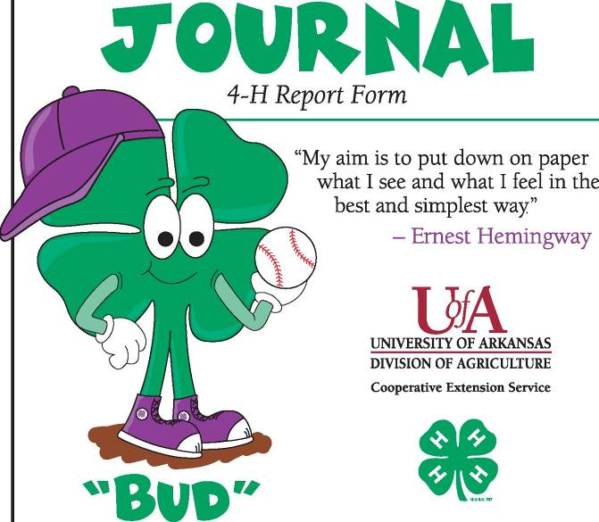
Name
Address
County
4-H Club |  |  | Age
Guide for Completing Your 4-H Clover Record Book
Keeping a 4-H record book is part of your overall 4-H Clover Bud experience. A 4-H Clover Bud record book is kept by 4-H’ers ages 5-8. A 4-H record book is an important part of completing each project. It is a written history of your project work. Keeping a 4-H record book helps you make plans (goals), be organized, make decisions, and just have fun.

Completing your 4-H Clover Bud Record Book can make you feel good about yourself. You did it! Your record book:

- Helps you earn credit for completing the 4-H year
- Makes you eligible to participate in other activities
- Helps you to be eligible to participate in other activities
- Helps you learn important life skills
- Gives you a chance to be recognized on the county level
- Helps you set higher goals – and more!

The 4-H Clover Bud Record Book should include:

- A standard 4-H cover – green Member’s Record Cover (purchase through the county office.)
- 4-H Clover Bud Record Book Report Form, pages 1-6.

4-H Report Form, pages 1-6

Report the last three years of your project work unless otherwise stated on the form. When preparing this report form, it should be handwritten, typed, or completed on a computer in this format. Do not repeat information. No additional pages can be added to this form.

My main 4-H project is: |  |  | My other 4-H projects are:
I went to |  |  |  | Club meetings, and they were about
I like being a Clover Bud because
2

Leadership – Check (X) the things you did.
Led the 4-H pledge
Led the pledge of allegiance
Led a song
Gave a talk
Gave a demonstration
Made a motion
Other
Other
Elected and Appointed Leadership
Were you a member of a committee in your club or a club officer? List them here.
Community Service
Community service is doing things for other people. List what you did.
3
Awards
List any awards won in 4-H
4-H Marketing
Who did you tell about 4-H? What did you do to promote 4-H?
Non-4-H Activities
(Like school, church, sports)
4

Show and Tell – Main Project
Draw, attach pictures, and/or make lists of things you did in your main project.
5
Show and Tell – Other Projects
Draw, attach pictures, and/or make lists of things you did in your other projects.
6
Materials adapted using record book guidelines from Arizona Cooperative Extension Service, Oklahoma Cooperative Extension Service, Tennessee Cooperative Extension Service, and Texas Cooperative Extension Service.

Committee Members

Jesse Clark, Hot Spring County
Donna Frances, Drew County
Angie Freel, Saline County
Lynelle Hallmark, White County
Jamie Martin, White County
Georgia Oldenstadt, Conway County
Connie Phelps, State 4-H Office
Bill Reed, Faulkner County
Janice Shofner, Benton County
Ruth Steely, Pike County
Carla Vaught, Polk County

The Arkansas Cooperative Extension Service offers its programs to all eligible persons regardless of race, color, national origin, religion, gender, age, disability, marital or veteran status, or any other legally protected status, and is an Equal Opportunity Employer.

